The Late Middle Pleistocene Mammalian Fauna Of Oumm Qatafa Cave, Judean Desert: Taxonomy, Taphonomy and Paleoenvironment
N. Marom, I.A. Lazagabaster, R. Shafir, F. Natalio, V. Eisenmann, L. Kolska Horwitz

Supplementary materials

- SI1: Bone measurements in mm. Abbriviations follow von den Driesch (1976). Vera Eisenmann’s mesurements of equid bones are presented by element in separate tables.
- SI2: R code and supplementary files for the morphometric analysis of OQ-75.
- SI3: R code and supplementary files for the maxent distribution modelling of O. rufescens.
- SI4: Comparison of diversity indices between Layers D and E.
- SI5: Aharon Horowitz’s preliminary report on the pollen sampled in 1991 from Layer D2.
- Supplementary figures:
Figure A: E. aff. capensis. OQ 122 (E2), left Tibia, A: anterior view, B: distal view; OQ 124 (E2), left Talus, C: posterior view, D: anterior view, E: distal view, F: medial view; G: OQ 123 (E2), left Calcaneum medial view. H: OQ 125 (?), first anterior Phalanx, profile. (Photographs by Roee Shafir and Vera Eisenmann).
Figure B: E. aff. capensis (A to I); Equus hydruntinus (J).
OQ 113 (E1) lower right dP4, A and B: occlusal view and scan; OQ 114 (E1) upper right dP4, C and D: occlusal view and scan; OQ 115 (E1) upper left dP4, E, F and G: occlusal view and scans; OQ 118 (F 32/23), H and I: section and vetibular view of a lower left molar germ. Equus hydruntinus, OQ 116 (E2/3), upper left dI3, J: occlusal view. (Photographs by Roee Shafir).
Figure C: Simpson's diagrams of E. (Asinus) aff. africanus from Aïn Metherchem, Tunisia and E. (Quagga) mauritanicus from Tighenif, Algeria MC. 1: Maximal length. 3: Breadth at the middle of the diaphysis. 4: Depth of the diaphysis at the same level. 5: Proximal breadth. 6: Proximal depth. 10: Distal supra-articular breadth. 11: Distal articular breadth. 12: Depth of the sagittal crest. 13: Least depth of the medial condyle. 14: Greatest depth of the medial condyle. n: number of specimens.

SI1: Bone measurements in mm.

Bos | astragalus | GLl | Bd | Dl
 | 255 | 87.6 | 58.4 | 47
 | scapula | Hmax | Hn | Glenoid H
 | 256 | 101.4 | 85.9 | 85.9
Canis | radius | Bd
 | 103 | 19.9
 | ulna | DPA | SDO | BPC
 | 104 | 18.8 | 16.2 | *12
 | mandible | dp4 L | dp4 B
 | 75 | 12.1 | 5.1
 | maxilla | dP4 L | dP4 B
 | 278 | 7.2 | 6
 | radius | Bp | Dp
 | 99 | 14.4 | 9.8
Capra | horncore base | L | B
 | 230 | 45.6 | 31.4
 | humerus | BT | HTC
 | 3 |  | 16.6
 | 204 | 39.9 | 17.1
 | 154 | 32.5 | 16.4
 | mandible | m3 L | m3 B
 | 209 | 29.3 | 10.7
 | 211 | 26.7 | 9.8
 | 166 | 27.1 | 10.1
 | 12 |  | 10
 | mandible | p3 L | p3 B
 | 30 | 8.4 | 5.6
 | maxilla | M3 L | M3 B
 | 36 | 19.8 | 12.6
 | 35 | 17.6 | 13
 | metacarpal | DEL | DVL | WCL | DEM | DVM | WCM | Bp
 | 53 | 13.3 | 20.5 | 17.9
 | 57 |  |  |  |  |  |  | 27.2
 | 201 |  |  |  | 11.4 | 18.7 |  | 31.7
 | 202 unfused |  |  |  |  |  |  | 28
 | ulna | BPC
 | 203 | 23.6
Cervidae cf. dama | pha-1 | GLpe | Bp | Bd | SD
 | 55 | 38.1 | 12.5 | 11.7 | 10.3
Cervus | mandible | tooth row (-P2) | P3 L | P3 B
 | 221 | 109.8 | 17 | 10
 | metatarsus | Bp
 | 217 | 42.1
 | 218 | 41
 | 219 | 39.6
 | pha-3 | DLS
 | 126 | 52.9
Dama | mandible | dp4 B
 | 9 | 8.6
 | metapodial | DEM | DVM | WCM
 | 162 | 14.7 | 2.9 | 18.4
 | metatarsal | Bp | Bd | Dd | DEM | DVM
 | 56 |  | 40.3 | 29.4
 | 41 |  | 30.9 |  | 15.1 | 21
 | 42 |  | 31.9 |  | 14.9 | 19.9
 | 43 |  | 31.2 |  | 15.5 | 20.9
 | 44 (unfused) | 28.2
 | 45 | 29.4
 | 220 |  | 45.5
 | pha-1 | GLpe | Bp | Bd | SD
 | 40 | 47.2 | 16.1 | 17.3 | 13
 | pha-2 | Bd
 | 180 | 12.6
 | radius | Bp
 | 52 | 61.5
 | 244 | 45.4
 | 223 | 44.5
 | tibia | Bd | Dd
 | 1 | 35.8 | 29.2
 | 6 | 34.9 | 28
 | 127 | 35.5 | 27.2
Equus | pha-1 | GL
 | 125 | 86.8
 | astragalus | BB | GH | LmT | BFd
 | 124 | 63.1 | 63 | 63.2 | 52.4
 | tibia | Bd | Dd
 | 122 | 72.9 | 51.9
 | mandible | M3 L | M3 B
 | 113 | 38.4 | 13
 | mandible | dp4 L | dp4 B
 | 118 | 30.1 | 11.1
 | maxilla | dp4 L | dp4 B
 | 120 | 21.1 | 20.9
 | maxilla | M1/2 L | M1/2 B
 | 119 | 26.5 | 22
Felis | humerus | SD
 | 112 (unfused) | 5.9
 | ulna | DPA | SDO | BPC
 | 111 | 13.7 | 12.1 | 9.6
Gazella | humerus | BT | HTC
 | 252 | 24.7 | 13.9
 | 253 |  | 13.3
 | mandible | dp4 L | dp4 B
 | 183 | 14.8
 | 187 | 16.1 | 5.5
 | metacarpus | Bd | Dd
 | 249 | 19.6 | 15.5
 | metatarsus | Bp | Dp | Bd | Dd
 | 3 | 20.2 | 23.3
 | 245 |  |  | 21.6 | 15.8
 | 247 | 21 | 23.5
 | 248 | 21.6
 | tibia | Bd | Dd
 | 250 | 22.9 | 19.1
 | 251 | 25.9 | 19.8
Crocuta | mandible | m1 L | m1 B
 | 88 | 30.06 | 14.2
 | mandible | p2 L | p2 B
 | 68 | 15.9 | 11.4
 | maxilla | P3 L | P3 B
 | 89 | 20.3 | 15.7
Procavia | calcaneus | GL
 | 74a | 26.8
 | femur | DC | SD
 | 261 | 9.6
 | 262 (p unfused) |  | 7.8
 | radius | GL | Bd | Bp | SD
 | 263 | 70.1 | 12.7 | 11.3 | 6.9
 | tibia | SD
 | 101(p d unfused) | 6.3
 | ulna | GL | BPC | SD | Dd | Bd
 | 74 (p d unfused) | 51.5 | 7.2 | 3.8
 | 264 |  |  |  | 8.7 | 8
Lepus | calcaneus | GL
 | 106 (unfused) | 25.7
 | humerus | Bd | HTC
 | 100 | 11 | 6.5
 | calcaneus | GL
 | 107 | 27.3
Ochotona | mandible | TRL | P3 alveolar L | P3 alveolar B
 | och_1 | 11.05 | 2.33 | 2.38
 | och_4 | 11.1 | 2.01 | 2.35
Stephanorhinos | radius | Bp | Dp | SD
 | 260 | 74.8 | 43.2 | 38.4
Vormela | ulna | DPA | BPC
 | 78 | 5.9 | 5.3
Vulpes | mandible | p3 L | p3 B | p4 L | p4 B
 | 85 | 8 | 2.6 | 8.5 | 4.1
 | maxilla | M1 L | M1 B
 | 110 | 12.6 | 6.4
 | radius | Bd
 | 86 | 12.9
 | 98 | 13.5

Procavia tooth measurements
Specimen ID | Tooth | Side | Wear | MD | BL | Hmax
OQ-293 | M3 | R | 0 | 9.1 | 8.1 | 6.9
OQ-277 | m2 | L | 1 | 7.9 | 5.1 | 6.4
OQ-282 | P4 | R | 0 | 7.8 | 6.5 | 5.7
OQ-283 | P3 | L | 0 | 6.7 | 6 | 5
OQ-285 | p4 | R | 0 | 6.2 | 3.4 | 3.8
OQ-273 | dp2 | R | 0 | 5.3 | 2.9 | 3.3
OQ-273 | dp3 | R | 0 | 6 | 3.4 | 3.6
OQ-274 | P4 | L | 0 | 7.9 | 6.3 | 4.9
OQ-275 | dP3 | L | 0 | 7.2 | 5.9 | 4.6
OQ-276 | P2 | R | 0 | 6.1 | 5.3 | 4.3
OQ-276 | P3 | R | 0 | 7 | 5.7 | 4.3
OQ-289 | dP1 | L | 0 | 4.5 | 3.5 | 3.3
OQ-292 | P2 | L | 0 | 6.6 | 5.5 | 4.3
OQ-291 | dP3 | L | 0 | 6.9 | 5.9 | 4.6
OQ-290 | dP3 | R | 0 | 6.7 | 5.4 | 4.8
OQ-288 | dP1 | L | 0 | 4.7 | 3.7 | 3.5
OQ-286 | I1 | R | 2 | 3.7 | 2.7 | 5.8
OQ-280 | p4 | L | 2 | 7.3 | 3.5 | 4.3
OQ-281 | p3 | R | 2 | 5.6 | 3.1 | 3.5
OQ-294 | m2 | R | 4 | 8.3 | 5.3 | 4.2
OQ-299 | P4 | L | 0 | 7.7 | 6.5 | 5.5
OQ-295 | P3 | R | 0 | 7.4 | 6.3 | 4.8
OQ-303 | P3 | L | 1 | 7 | 5.7 | 4.5
OQ-304 | P3 | L | 0 | 7.1 | 5.8 | 4.6
OQ-297 | P2 | R | 0 | 6.4 | 5.3 | 4.5
OQ-300 | P4 | L | 0 | 7.3 | 6.5 | 5.3
OQ-306 | p2 | R | 1 | 5.6 | 2.8 | 4
OQ-302 | p3 | L | 2 | 6.8 | 3.3 | 3.9
OQ-301 | dp4 | L | 1 | 6.2 | 3.4 | 4.5
OQ-296 | dp4 | L | 1 | 6.1 | 3.4 | 4.2

Equid Measurements (V. Eisenmann)

Layer | E2
Talus | OK 3
Greatest length | 66
Medial length of trochlea | 63.5
Maximal width | 63
Trochlear width | 31
Distal articular width | 53
Distal articular depth | 37
Medial depth | 54

Layer | E2
Calcaneum | OK 2
Greatest length
Length of proximal part | 78
Smallest breadth | 21.5
Proximal breadth | 45
Poximal depth | 37.5
Distal depth | 55
Distal breadth | 53
Max. diam. sustentaculim tali | 37
Articular diam. sustentaculum

MC or MT III
Layer |  | D1
Measurements (mm) |  | Vaufrey
Greatest length | 1
Mid-shaft width | 3
Mid-shaft depth | 4
Proximal width | 5
Proximal depth | 6
Articular facet for tarsale III | 7
Maximal distal width | 10
Distal articular width | 11 | 39
Distal depth | 12
Medial condyle minimal depth | 13
Medial condyle maximal depth | 14
Lateral condyle minimal depth | 13 bis

 | Ant
Layer |  | D1
First Phalanges | OK 4 | Vaufrey
Greatest length | 88 | 70
Anterior length | 81
Smallest breadth | [33]
Proximal breadth | [50]
Poximal depth | [35]
Distal supra-articular breadth | [40]
Greatest length of trigonum phalangis | [60]
Smallest length of trigonum phalangis
Posterior length
Medial supratuberosital length | 67
Laterial supratuberosital length
Medial infratuberosital length | 12
Lateral infratuberosital length
Distal articular breadth | [38]
Distal articular depth

Layer | E2
Tibia | OK 1
Greatest length
Lateral length
Smallest breadth | 45
Smallest depth
Proximal breadth
Proximal depth
Distal breadth | 72.5
Distal depth | 51.5
Length pf fossa digitalis
Breadth of fossa digitalis
Medial length

 |  |  | Length | Postflexid | Width | Height | Layer
dP4 | D | OK 8 | 33 | ~ unworn | 13.5 | 37 | E2
M1 | G | OK 14, 45v |  | 7.5 | 12 | ca 47 | D2
M2 | G | OK 15, 46 | 29 | 8.1 | 11 | ca 39 | F32/23
G=gauche=left
D=droite=right

 |  |  | Pli cab. | Plis fosseette | Length | Width | Protocone | Height | Layer | Vaufrey
dP3-4 | D | OK 16 |  | unworn | 29 | 21.5 | 11 | 27 | E1
dP4 | G | OK 7 |  | ~ unworn | 32 | 24 | 9 | 26 | E2
P | D | OK 5 | + | 7 | 28 | 26.2 | 13.8 | 51
M | G | OK 6 | 0 | 4* | 26* | 27* | 11* | 81 | D2
fragt |  | OK 9 |  |  | 25* | 27* | 11* | unworn
fragt | G | OK 11 |  | 4 | 20.5 |  |  | 47 | D2/50
 | G | OK 12 |  |  | small |  |  | ~ unworn | D2/37
M | D | OK 13, 47v | 0 | 2 | 18.7 | 20.1 | 7.2 | 33 | D2/20
P | D |  | + | 7 | 27.5 | 24 | 10 |  | D1 | Fig. 33 left
M | G |  | 0 | 5 | 26 | 25 | 10 |  | D1 | Fig. 33 right
G=gauche=left
D=droite=right
*at mid-height or section

Teeth:

SI2: R code and supplementary files for the morphometric analysis of OQ-75.

R files and code are at https://doi.org/10.5281/zenodo.5553154
Specimen information
origin | catalogue | species | genus | Country | GL | Wi | Wii
OQ |  | OQ | OQ |  | 12.34 | 5.16 | 3.79
SMNH | M-5236 | Ly_pictus | Lycaon |  | 14.3 | 4.65 | 3.37
SMNH | M-3997 | Ly_pictus | Lycaon |  | 15.01 | 5.2 | 4
SMNH | M-3996 | Ly_pictus | Lycaon |  | 16.17 | 5.75 | 3.97
MMBF | MMBF-9338 | Ly_pictus | Lycaon |  | 14.34 | 4.86 | 3.65
ZMB | ZMB-022397 | C_lupus | Canis |  | 12.04 | 4.22 | 3.53
ZMB | ZMB-16675 | C_dingo | Canis | Australia | 12.45 | 5.19 | 4.03
ZMB | ZMB-19912 | Lu_adusta | Lupulella | Tanzania | 9.89 | 3.5 | 3.88
ZMB | ZMB-23340 | V_vulpes | Vulpes | Poland | 9.62 | 3.67 | 2.71
ZMB | ZMB-2685 | C_lupus | Canis | Germany | 14.98 | 5.5 | 5.26
ZMB | ZMB-40439 | Lu_adusta | Lupulella | Senegal | 11.21 | 4.29 | 2.67
ZMB | ZMB-40440 | Lu_adusta | Lupulella | Senegal | 11.96 | 4.4 | 2.73
ZMB | ZMB-40466 | Lu_adusta | Lupulella | Senegal | 9.51 | 3.71 | 2.24
ZMB | ZMB-40467 | Lu_adusta | Lupulella | Senegal | 10.61 | 3.96 | 2.53
ZMB | ZMB-40468 | Lu_adusta | Lupulella | Senegal | 9.57 | 3.41 | 2.25
ZMB | ZMB-41025 | U_cinereoargenteus | Urocyon | No locality | 8.71 | 3.27 | 2.55
ZMB | ZMB-48509 | N_procyonoides | Nyctereutes | No locality | 8.47 | 3.27 | 2.13
ZMB | ZMB-4861 | N_procyonoides | Nyctereutes | No locality | 8.42 | 3.18 | 2.14
ZMB | ZMB-5057 | C_lupus | Canis | Germany | 15.03 | 5.5 | 5.09
ZMB | ZMB-52484 | C_latrans | Canis | Mexico | 11.69 | 4.39 | 3
ZMB | ZMB-5525 | U_cinereoargenteus | Urocyon | United States | 8.14 | 2.98 | 2.24
ZMB | ZMB-56633 | A_lagopus | Alopex | Greenland | 8.76 | 2.94 | 2.34
ZMB | ZMB-65218 | C_latrans | Canis | Mexico | 11.49 | 4.02 | 2.7
ZMB | ZMB-65663 | V_vulpes | Vulpes | Palestine | 9.15 | 3.22 | 2.58
ZMB | ZMB-65844 | Lu_mesomelas | Lupulella | Namibia | 10 | 3.77 | 1.95
ZMB | ZMB-7341 | V_vulpes | Vulpes | Poland | 9.83 | 3.68 | 2.6
ZMB | ZMB-7342 | V_vulpes | Vulpes | Poland | 9.22 | 3.35 | 2.57
ZMB | ZMB-754 | C_lupus | Canis | No locality | 16.58 | 5.85 | 3.94
ZMB | ZMB-85793 | C_lupus | Canis | No locality | 15.4 | 5.11 | 3.88
ZMB | ZMB-86261 | C_lupus | Canis | Canada | 17.04 | 6.37 | 4.9
ZMB | ZMB-86264 | C_lupus | Canis | Palestine | 14.58 | 5.43 | 3.51
ZMB | ZMB-871 | A_lagopus | Alopex | No locality | 9.09 | 2.89 | 2.51

OQ = Oumm Qatafa; SMNH = Steinhardt Museum of Natural History; ZMB =Zoological Museum Berlin

SI3: R code and supplementary files for the maxent distribution modelling of O. rufescens.

R files and code can be found at https://doi.org/10.5281/zenodo.5842183

SI4: Comparison of diversity indices between Layers D and E.

Layer | Layer_E | Layer_D
Stephanorhinus | 0 | 1
E_ferus* | 3 | 2
E_hydruntinus | 0 | 2
Cervus | 1 | 2
Dama | 5 | 5
Capra | 7 | 22
Gazella | 2 | 7
Bos | 1 | 2
Antelopini | 0 | 1
Procavia | 29 | 10
Lepus | 0 | 2
Ochotona | 6 | 2
Crocutta | 1 | 1
Canis | 4 | 1
Vulpes | 2 | 1
Felis | 1 | 0
*The equid taxa were collapsed to assinine and caballine groups.

 | Layer_E | Layer_D | Perm p(eq)
Taxa S | 12 | 14 | 0.497
Individuals | 62 | 60 | 0
Dominance | 0.257 | 0.1911 | 0.1382
Shannon H | 1.842 | 2.069 | 0.2833
Evenness e^H/S | 0.5257 | 0.5653 | 0.6286
Simpson indx | 0.743 | 0.8089 | 0.1382
Menhinick | 1.524 | 1.807 | 0.358
Margalef | 2.665 | 3.175 | 0.358
Equitability J | 0.7412 | 0.7839 | 0.4433
Fisher alpha | 4.433 | 5.743 | 0.358
Berger-Parker | 0.4677 | 0.3667 | 0.1967

SI5: Preliminary report on the pollen sampled in 1991 from Layer D2. Courtesy of A. Horowitz.

Arboreal pollen | %
Quercetalia | 10
Conifers | 90
Regional pollen | %
Arboreal pollen | 30.3
Steppe pollen | 27.3
Desert pollen | 42.4
Local pollen | %
Hydrophilic | 3.3
Graminacea & Cyperaceae | 80
Chenopodaceae | 16.7
Total pollen | %
Local | 47.6
Arborel | 15.9

Supplementary Figure A
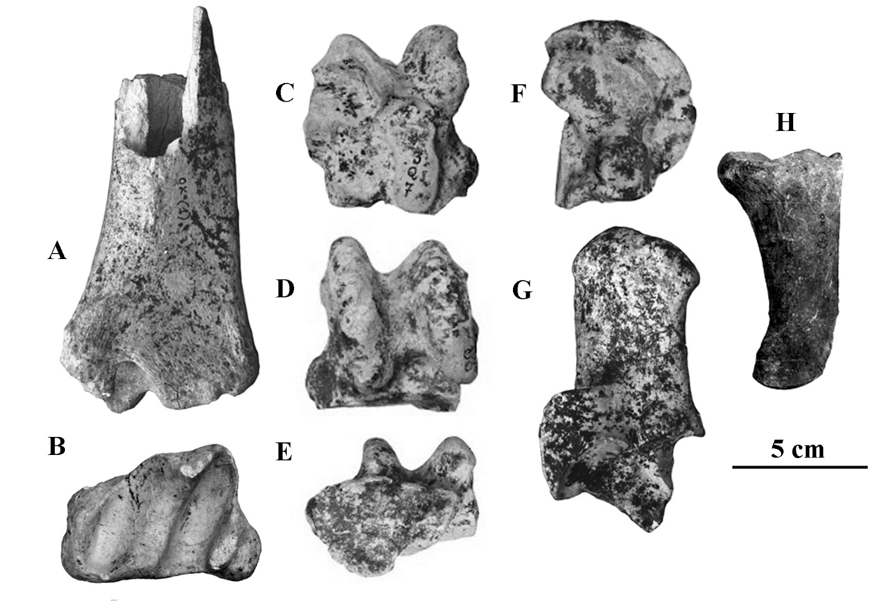

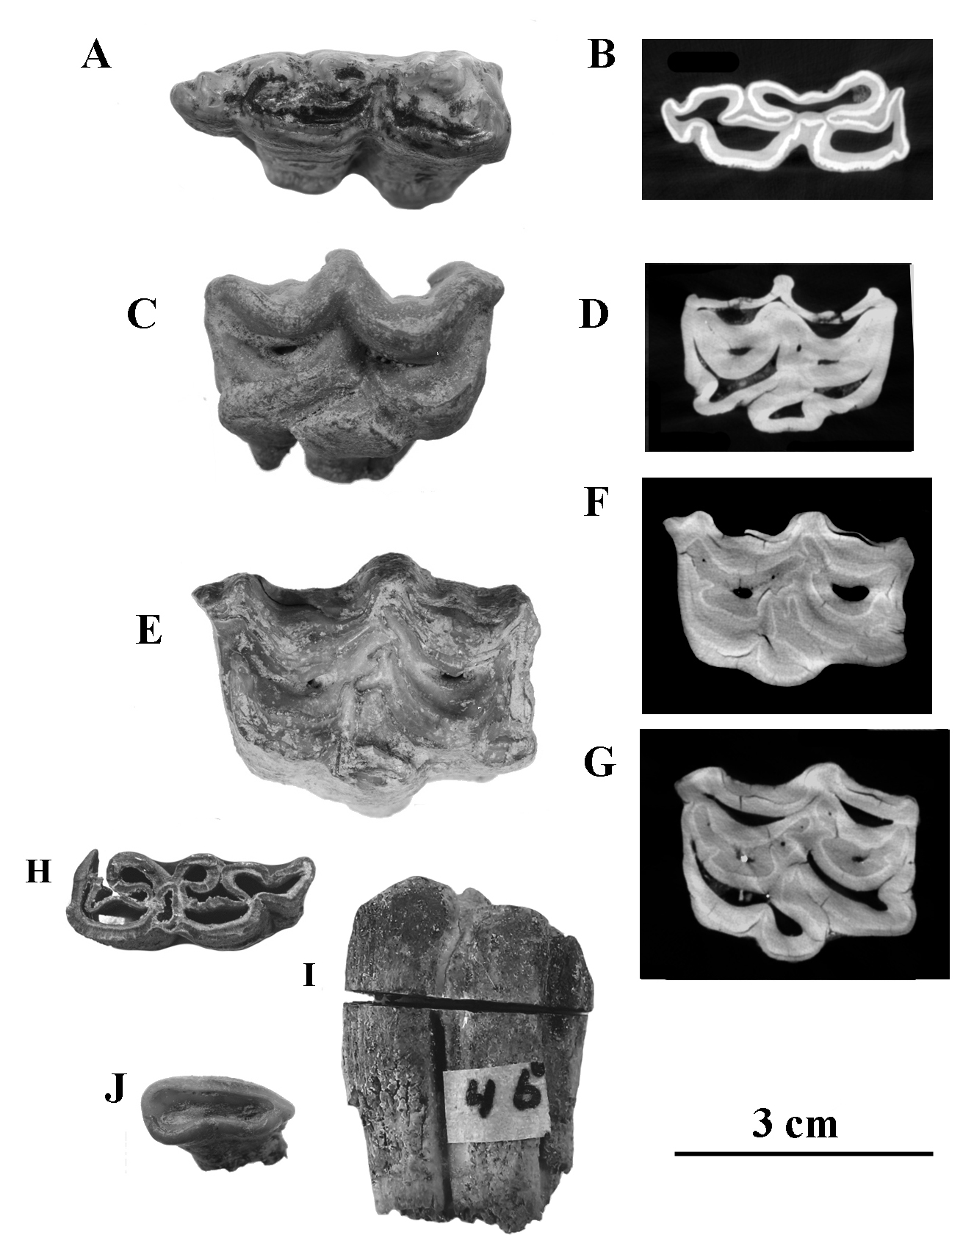
Supplementary Figure B

Supplementary Figure C

