204

- The lower I1 and I2 have no cups.

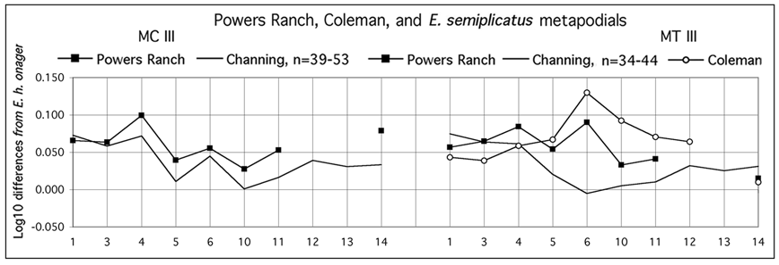

Figure 55. Ratio diagrams of A. pseudaltidens (Powers Ranch, Coleman) and E. semiplicatus (Channing) third metapodials. n=number of specimens. Data in Tables 3, 4, 6.

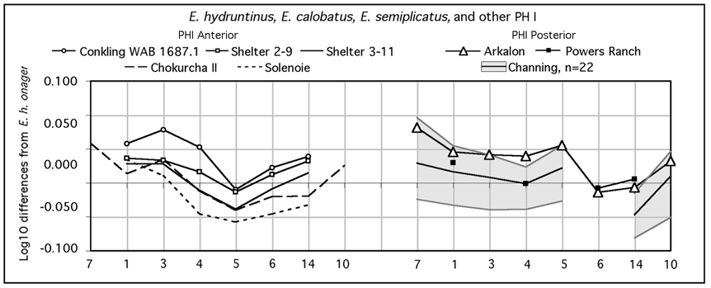

Figure 56. Ratio diagrams of first phalanges of E. hydruntinus (Chokurcha II, Solenoie), Equus sp. (Conkling, Shelter), E. calobatus (Arkalon), A. pseudaltidens (Powers Ranch), and E. semiplicatus (Channing). Data in Tables 5-6.

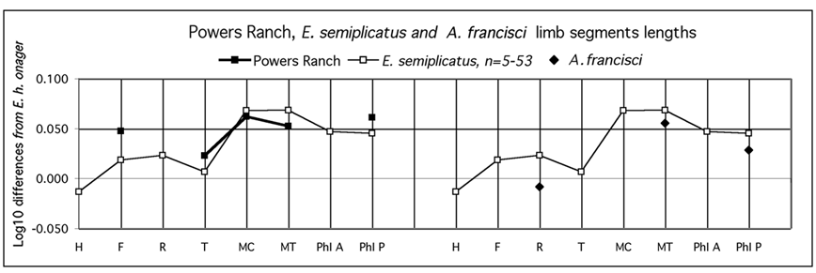

Figure 57. Ratio diagrams of A. pseudaltidens (Powers Ranch), E. semiplicatus (Channing), and A. francisci limb bones lengths. Data in Table 2.

205

The referred metapodials (BEG 31186-3 and 7) are long and slender but their proximal and distal ends are not so small (Figure 55). Winans (1985) gave the dimensions of a MT from Coleman, Florida (Irvingtonian) that seems close to the Powers Ranch MT dimensions.

- The posterior first phalanx also has a more developed distal end than either E. calobatus or E. semiplicatus (Figure 56 right).

- Metapodials are long relative to the femur and tibia, but not as much as at Channing (Figure 57 left).

Althogether, these limb bones seem intermediate between those of typical stilt legged forms and extant hemiones. Their referral to the type teeth could be questioned because another upper premolar (BEG 31186-13), referred to E. littoralis, was found at the same locality. Its enamel pattern (Figure 54-3) is more consistent with what can be expected from the proportions of the limb bones but the size is too small (21.6mm). In conclusion, the association of cheek teeth absolutely not hemione-like with slender limb bones is unusual in Equus. The occurrence of a pli protostylid on P/2 and the lack of cups, however, point to an affinity with Amerhippus. If so, we have now another slender Amerhippus, beside A. francisci.

2. Amerhippus sp. of Natural Trap, Wyoming, ca 12 Ka.

There is evidence for the presence of four species at Natural Trap:

- a caballine represented by the upper and lower series UNSM 51079 and by a fragment of mandible UNSM 47238 with cups on the incisors;

- a large Amerhippus;

- an E. cf. conversidens;

- a small Amerhippus, to which belong most specimens.

a. Large Amerhippus
- A badly-preserved skull (UNSM 51330) is very large (basilar length: 552mm) but rather narrow. The auditive meatus seems very small (not figured on Fig. 58). The muzzle is long and uncommonly wide. The skull, such as it appears, resembles a specimen of Amerhippus of Tarija, Bolivia (Chicago Field Museum PM 142-14). The corresponding distal articular widths of metapodials should be more than 45mm (Appendix 4).

- Cheek teeth
The associated series UNSM 56806 VY are not quite adult. The teeth are large (176mm for the lower series). The metaconids of M/1 and M/2 are elongated (and bilobated on M/1), as in some specimens from Loufangzi and from Amerhippus (Figs. 23a-b, 59).

- This large species was vey probably slender form as shown by five humeri, one radius, three tibiae, and three third phalanges (UNSM 31447 - probably anterior; 50818 and 52567 - probably posterior; Fig. 65). According to correlations in extant slender

206

species the diistal articular width of third metapodials would have been: MC11 around 45-45.5; MT11 around 44-44.5. One slender MC (UNSM 50987) probably belongs to this species (Fig. 62). The large and slender equid of Natural Trap is too poorly represented for a discussion of its proportions (Fig. 66).

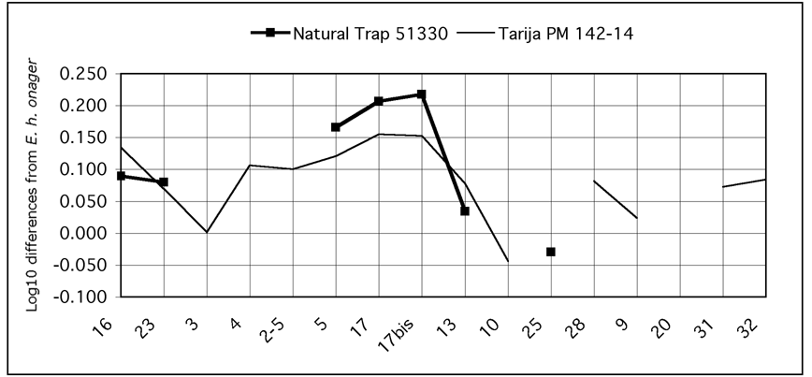

Figure 58. Ratio diagrams of Natural Trap and Tarija skulls. Data in Table 7.

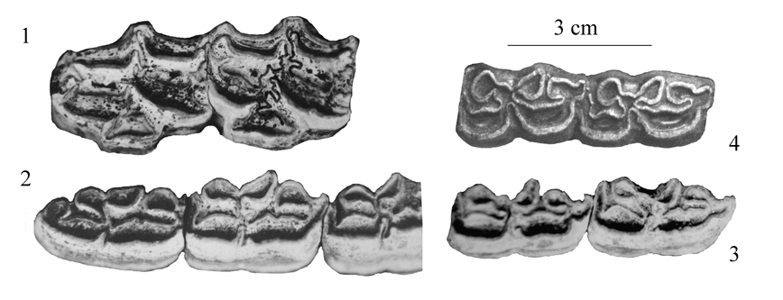

Figure 59. Associated upper and lower cheek teeth UNSM 56806 (1-3) and lower M1-M2 (4) of Amerhippus (PA Ecuador, Oil Fields).

b. Small Amerhippus
It is well represented by a mandible, without cups on the incisors (Fig. 60).

On the basis of the mandible dimensions, the skull basilar length was about 437mm (Appendix 1, 3). Probably belong to the same species the lower P2-P4 UNSM 42589.

Average dimensions of twelve MC were given by Winans (1985) but we have now the data on 49-57 MC and 58-64 MT from Natural Trap measured by one of us (JH). There are also data on other limb bones. We will consider only the gracile
207

specimens. Their variation is very large. We have tried to sort them as well as we could.

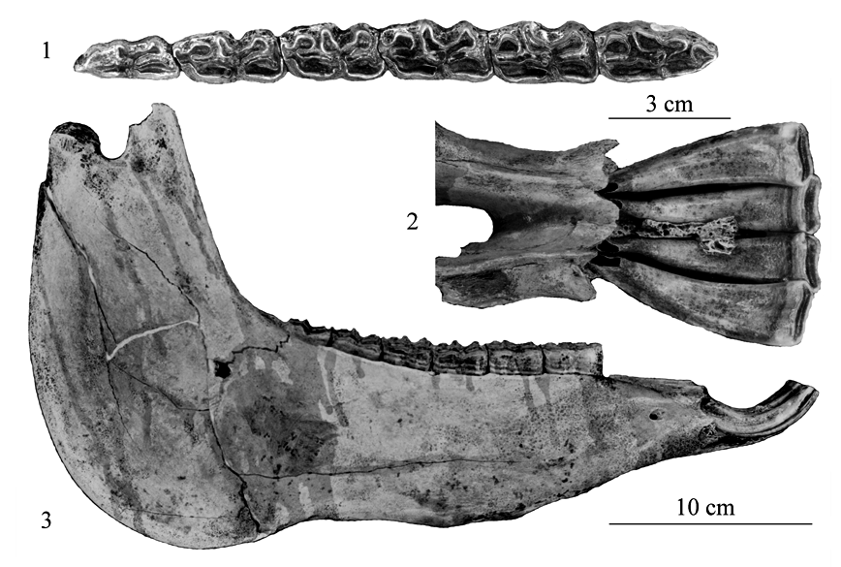

Fig. 60. Small Amerhippus from Natural Trap, NT 500NW515. 1: Lower cheek teeth. 2. Symhysis. 3: Mandible.

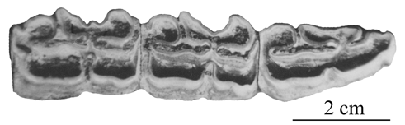

Fig. 61. Small Amerhippus from Natural Trap, UNSM 42589, lower P2-P4.

- Five metacarpals have abnormally small widths. Possibly they were pathological or not quite mature; they were ignored. One individual (represented by right and left metacarpals) has strange proportions (UNSM 57642); it was not included in the statistics. Another (also represented by right and left metacarpals has deeper distal ends than the rest (UNSM 50987) and was referred to the large Amerhippus. The rest of gracile metacarpals (n=46-52) may be considered as a homogeneous sample (Fig. 62). The bulk of slender MC are close in size and proportions (Figure 64 left) to extant Mongolian hemiones, E. hemionus hemionus, to slender equids from Yukon and Alaska (Dawson 37: NMC 35468, 35497, 35397, Dawson unknown locality: NMC 36155); (Gold Run: NMC 13472-32), and, surprisingly enough, from Pool Branch, Florida (Winans 1985).

208

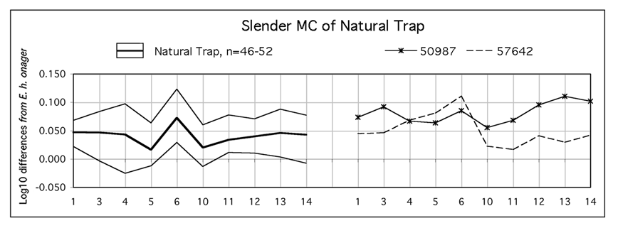

Figure 62. Ratio diagram of Natural Trap slender MC III mean and range of variation (n=number of specimens) and of two other MC III. Data in Table 8.

- Three metatarsals (UNSM 50817 and 52203, very probably of the same individual, and UNSM 32818) have deeper distal ends than the rest. Another (UNSM 52327) is smaller and more robust (Fig. 63). Many are abnormally flat. They were not included in the statistics. The rest of gracile metatarsals (n=34) may be considered as a homogeneous sample.

The bulk of slender MT of Natural Trap are also similar to extant hemiones (Figure 64 right) but with deeper proximal epiphyses and diaphyses. So are the MT of Dawson: NMC 25178-16 (associated to a posterior first phalanx NMC 24177), 25188-13, 34775-?, 35498-37, 37835-39, 35626-40) described by Harington & Clulow (1973).

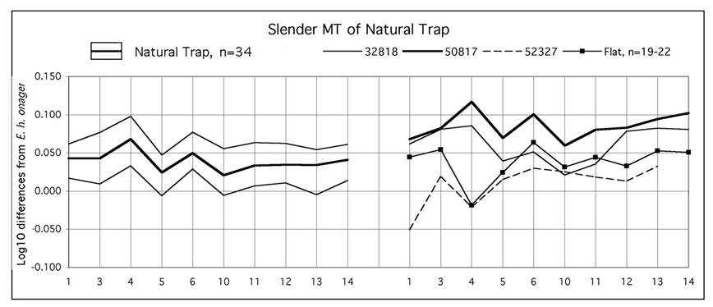

Figure 63. Ratio diagram of Natural Trap slender MT III mean and range of variation (n=number of specimens) and other MT III. Data in Table 8.

- First Phalanges (PH1)
Again several gracile specimens (UNSM 31447 - probably anterior; 50818 and 52567 - probably posterior) differ from the bulk and were referred to the large

209

Amerhippus. For the rest, means of anterior phalanges of Natural Trap and extant E. hemionus hemionus are close; those of posterior phalanges are more different (Fig. 65).

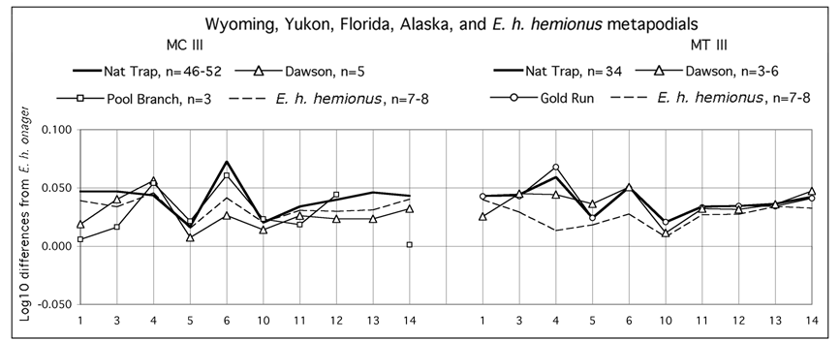

Figure 64. Ratio diagrams of Equus and/or Amerhippus sp. (Natural Trap, Dawson, Gold Run, Pool Branch) and E. hemionus hemionus third metapodials. Data in Tables 3, 4, 8.

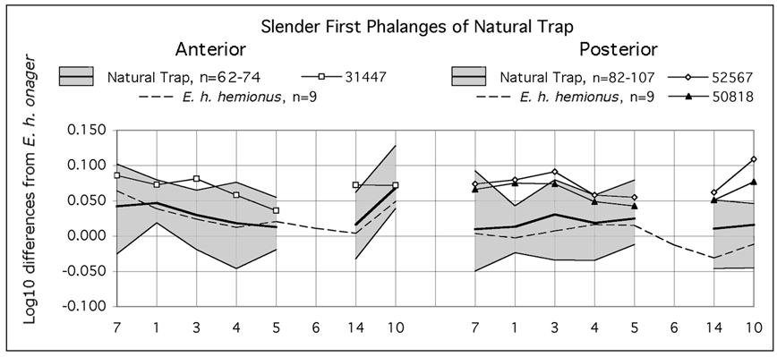

Figure 65. Ratio diagram of Natural Trap slender PH1 mean and range of variation (n=number of specimens) and other slender PH1. Data in Table 8.

- The limb bones proportions (Fig. 66) of the best represented equid of Natural Trap are not those of a stilt-legged equid: metapodials and first phalanges are not elongated relatively to proximal bones as they are in E. pseudaltidens of Powers Ranch. The slender equid of Natural Trap had hemione-like proportions.

c. Interpretation
- Because of several lower cheek teeth characters and of the lack of cups, we refer to Amerhippus sp. the bulk of equid remains from Natural Trap. If so, that is the third
210

known slender Amerhippus. It was not a stilt-legged equid equid, its limb bones proportions being more hemione-like.

- We refer also to Amerhippus the large and slender form, much less documented but whose fragmentary skull resembles a specimen from Tarija (Bolivia).

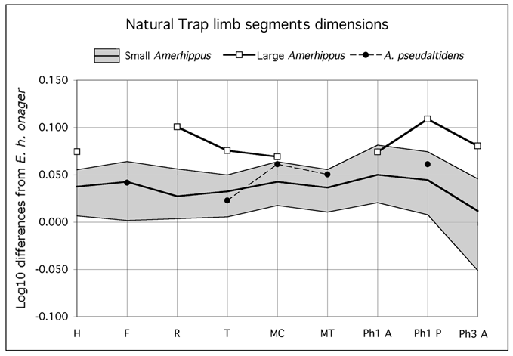

Figure 66. Ratio diagram of limb bones lengths and third anterior phalanx width. H: humerus, F: femur, R: radius, T: tibia, MC: third metacarpal, MT: third metatarsal, Ph1 A: first anterior phalanx, Ph1 P: first posterior phalanx, Ph3 A: third anterior phalanx. Data in Table 2.

V. INCERTAE SEDIS AND HEMIONE-LIKE EQUUS

As we have seen, stilt-legged forms are characterized by the relative lengths of their limb bones. When no information exists on the lengths of humerus, radius, femur, or tibia, it is difficult to decide whether some slender equid belonged to the stilt legged group or to hemione-like one.

1. Equus sp. B of Leisey Shell Pit A, Florida

Hulbert (1985) described as Equus sp. B teeth and metapodials from this Irvingtonian locality (around 1.2 Ma).
- The muzzle was probably about 120mm long and very wide. All lower incisors have well developed cups (Fig.67).
- The upper cheek teeth have no pli caballin and long protocones; the lower cheek teeth have shallow ectoflexids and rather zebra-like double knots. Upper and lower P2 are rather short like in E. semiplicatus (Fig.68). On the basis of cheek teeth length, the

211

skull basilar length was 400-450mm.

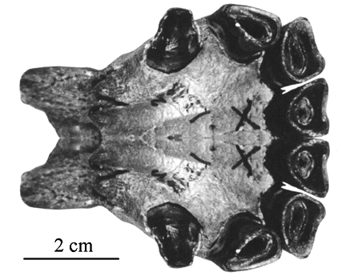

Figure 67. Mandibular symphysis of Equus sp. B from Leisey Shell Pit A, UF 85785, adapted from Hulbert (1985).

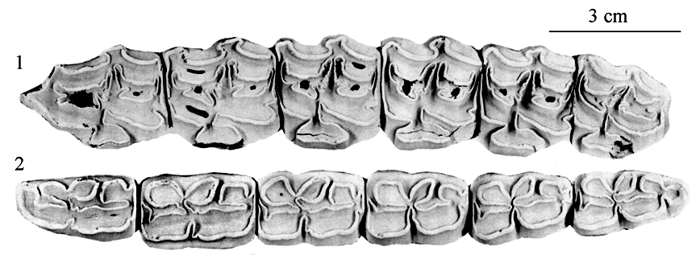

Figure 68. Upper and lower cheek teeth of Equus sp. B. 1: UF 80850. 2: UF 83309. Adapted from Hulbert (1985).

- As noted by Hulbert, metapodials resemble hemiones, and also E. hydruntinus (Fig.69).

A MT from Fossil Lake, Oregon, (UCMP 2437) and another from Ingleside Pit, Texas (BEG 30907-6) published by Quinn (1957) may belong to the same form. There again, there is some likeness with E. hydruntinus but the distal epiphyses are larger. Pending information on the other limb bones, it is impossible to say whether Equus sp. B belonged to the stilt legged group.

2. Equus sp. of Conkling and Shelter, New Mexico, Plum Point Interstadial?

Data (Table 5) were kindly provided by A. Harris. Three first phalanges, if they are anterior, compare well with two specimens belonging to E. hydruntinus (Fig.56 left).

212

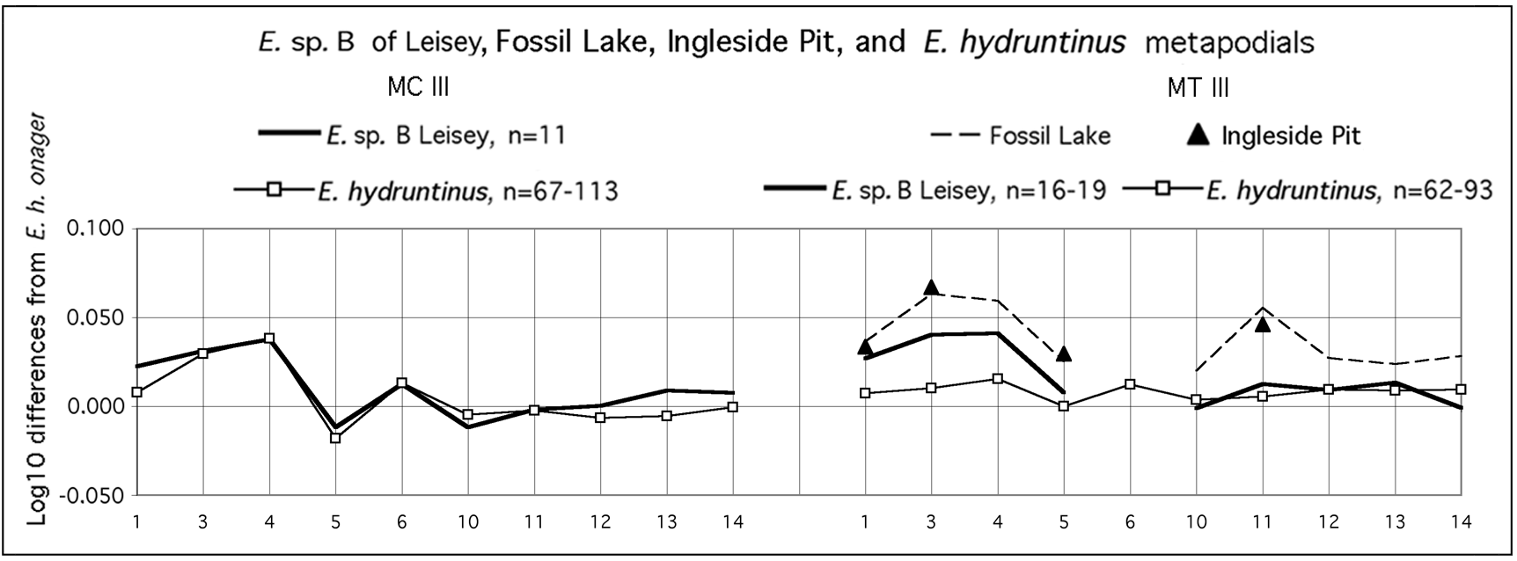

Fig. 69. Ratio diagrams of Equus sp. B, E. hydruntinus, and other (Fossil Lake, Ingleside Pit) third metapodials. Data in Table 3-4.

DISCUSSION AND CONCLUSIONS

1. Summary of characters

- Skull and teeth
The following table (Fig.70) summarize the main characters we used in comparing Old World Hemiones to slender New World equids.

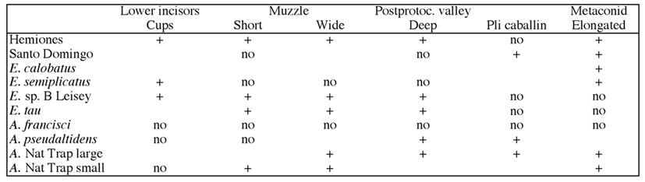

Fig.70. Comparison of main skull and teeth characters in hemiones and New World slender equids.

It shows that there is no New World equid presenting all Hemiones characters, the closest being E. tau and the most unlike Hemiones - A. francisci.

- Third metapodials (Fig.71)
Stilt metapodials differ from Old World extant hemiones by deep diaphyses (4) at least on MC III, relatively more narrow proximal epiphyses (5) and often by relatively larger distal articular breadths (11). By these features they resemble more E. hydruntinus. In the not-stilt-legged Amerhippus of Natural Trap (Fig.64) proximal depths are especially developed.

213

- Limb segments proportions
The extreme elongation of metapodials relative to proximal bones (Fig.32, 57) has never been found yet elsewhere than in the New World. It exists since the Late Blancan and is present in A. francisci which, however, differs by its skull from other stilt-legged equids.

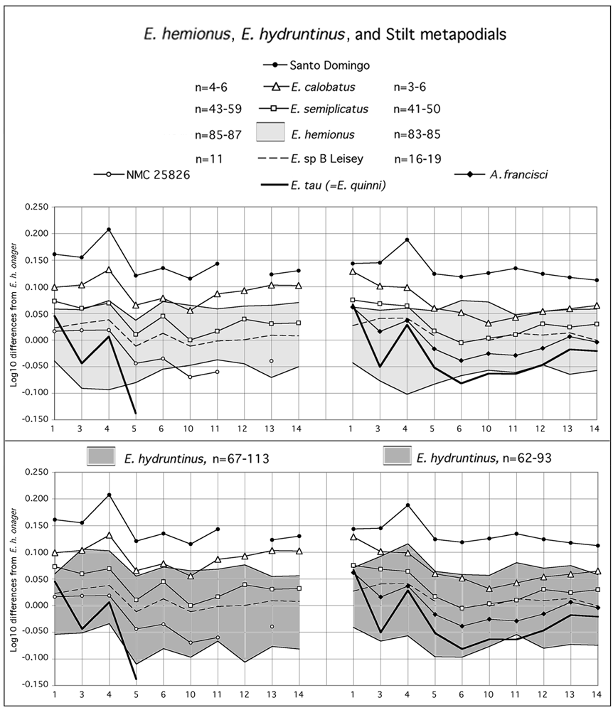

Figure 71. Ratio diagrams of various New World slender Equus compared to Old World E. hemionus and E. hydruntinus third metapodials. Data in Tables 3, 4, 6, 8.

214

2. Discussion

A recent molecular study (Weinstock et al. 2005) brings evidence supporting the endemy of all North American stilt-legged and hemione-like equids (NWSL for short). Three calibration points based on paleontological data are used for divergence date estimations:
- 55 Ma for most recent common ancestor (MRCA) of rhinoceroses and equids,
- 3 or 4 Ma for MRCA of hippidion and NWSL,
- 1.3 Ma for the base of the caballine clade.

Old World zebras, asses, and hemiones form a basal polytomy, anterior to the node uniting hippidions, NWSL, and caballines, i.e. before 3 to 4 Ma.

From a zoological point of view, it is difficult to admit that caballines are closer to hippidions than to Old World hemiones, asses, and zebras; and even more that they interbreed with the latter after a separation of more than 3 Myr. This proximity is as astonishing as that previously found between hippidions and Old World hemiones (Orlando et al. 2003). Let us note that in that paper the studied hippidion bones were eventually (and reluctantly) assigned to Amerhippus by one of the authors (VE), precisely because of the surprise caused by the molecular results. It is also difficult to accept that there is nothing more than a convergence between NWSL and Old World hemiones. Admittedly, cursorial adaptations may develop in parallel. But the quite peculiar occlusal pattern of the lower cheek teeth, appearing now and again in New World (Fig. 72-1,3,4), and Old World equids (Fig. 72-2,5,6), looks more like a common genetic character than a parallelism.

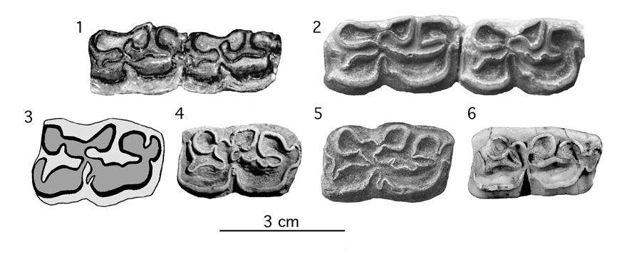

Figure 72. New and Old World lower cheek teeth. 1: Dry Mountains, AMNH 116502, P3-P4, adapted from Azzaroli & Voorhies 1993. 2: Venta Micena, VM 84 C3 B9 12. P3-P4. 3: Arkalon Gravel Pit, UMMP 29069, M1, adapted from Hibbard 1953. 4: Tarija, V 689, P4. 5: Choukoutien, IVPP-CKT 1930-5, P3 or P4. 6: E. kiang, FMNH 182, M1.

3. Conclusion

We propose that Old World hemiones, Sussemiones, Amerhippus, and NWSL have a common origin in the Late Blancan of North America (Fig.73).
215

- Amerhippus have originated in North America, posibly from forms like AMNH 116502 of Dry Mountains, Arizona (Fig. 33-1). Some of them became slender, like the Powers Ranch A. pseudaltidens, A. francisci, and the Natural Trap Amerhippus.

- Sussemiones possibly differentiated in Beringia as suggested by the lower cheek series found at Lost Chicken, Alaska (Fig. 33-5). They were extremely successful and dispersed into all Eurasia and Africa (Eisenmann 2006b). Only part of them (E. granatensis group) adapted to dry environments, acquiring slenderness, cursorial proportions, and relatively simple enamel pattern on the upper cheek teeth. Other (E. coliemensis group) exhibit large size and extremely complicated enamel patterns possibly related to humid conditions.

- In North America, true stilt-legged Equus (E. calobatus, E. cf. calobatus, E. semiplicatus) originated also during the Late Blancan, as shown by the Equus of Santo Domingo.

- Equus sp. B of Leisey does not look like a true stilt-legged equid. It may be at the origin of E. tau.

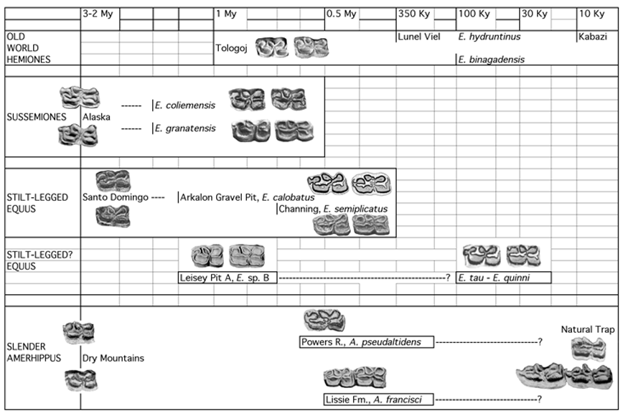

Figure 73. Possible relationships between New and Old World equids.

- Old World hemiones differentiated later, either from a yet unknown Beringian ancestor (not necessarily slender !), or from a North American migrant that could have resembled Equus sp. B of Leisey. The Old World hemiones may be defined, in addition to slenderness and cursorial proportions, by the shortness of the muzzle, the development of deep post-protoconal valleys and loss of pli caballins on the upper

216

cheek teeth. E. hydruntinus is apomorphic by microdonty, short protocones, and shallow ectoflexids on molars.

APPENDIX

When one has to deal with fossil samples where some bones or informations are missing, it may be convenient to 'guess' the missing dimensions. Although correlations between size of bones, skulls, or dentitions are not precise, they do exist and render possible some estimations.

The following scatter diagrams illustrate these correlations. They are based on extant Equus associated material.

1. Relations between basilar length of the skull and maximal length of the mandible (A) and between the skull muzzle length and the mandibular muzzle length (B).

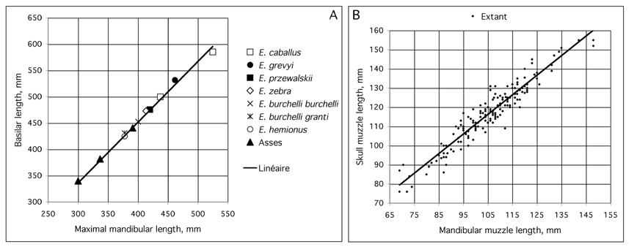

Appendix Fig. 1. (A) is based on average dimensions observed in 61 E. caballus, 55 E. grevyi, 37 E. przewalskii, 59 E. zebra, 27 E. africanus, 31 E. burchelli granti, 31 E. burchelli burchelli, 28 E. hemionus kulan, and 52 E. asinus. We have added a minimum value (E. asinus) and a maximum value (E. caballus). (B) is based on 38 E. caballus, 9 E. grevyi, 35 E. przewalskii, 9 E. zebra, 9 E. africanus, 19 E. burchelli burchelli, 24 E. hemionus kulan, and 19 E. asinus.

Being based on average values, the (A) correlation is especially good: R2=0.9836. The basilar length (y) = maximal mandibular length (x) * 1.525 - 9.5315.
The (B) correlation is good enough: R2=0.893. The skull muzzle length (y) = mandibular muzzle length (x) * 1.0277 + 8.3459.

2. Relation between Basion-vomer distance and Postorbital line length.

217

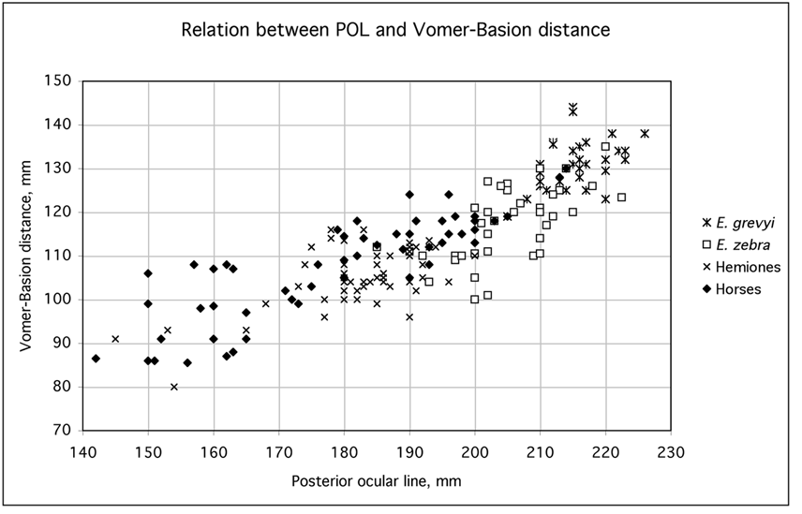

Appendix Fig. 2. Scatter diagram (in mm) of Basion-vomer distance versus Postorbital line length based on 32 E. grevyi, 41 E. zebra, 51 hemiones (E. hemionus and E. kiang), and 55 Horses (12 E. przewalskii and 43 E. caballus).

The correlations is not so good: R2=0.744. A rough estimation of the Basion-vomer distance is however possible. The Basion-vomer distance (y) = Postorbital line length (x) * 0.5732 + 3.236.

3. Relation between cheek teeth length and skull basilar length
The correlation is R2=0.8161. The basilar length (y) = cheek teeth length (x) * 3.8974 - 154.53. The cheek teeth length (y) = basilar length (x) * 0.2094 + 61.78.

4. Relation between metapodial distal articular width and skull basilar length.
The correlation for MC is R2=0.8153. The distal artcular width of MC (y) = basilar
length (x) * 0.0726 + 7.4217. The basilar length (y) = distal artcular width of MC (x) * 11.227 - 0.1552.

The correlation for MT is R2=0.8511. The distal artcular width of MT (y) = basilar
length (x) * 0.0782 + 4.0611. The basilar length (y) = distal artcular width of MC (x) * 10.885 + 22.901.

218

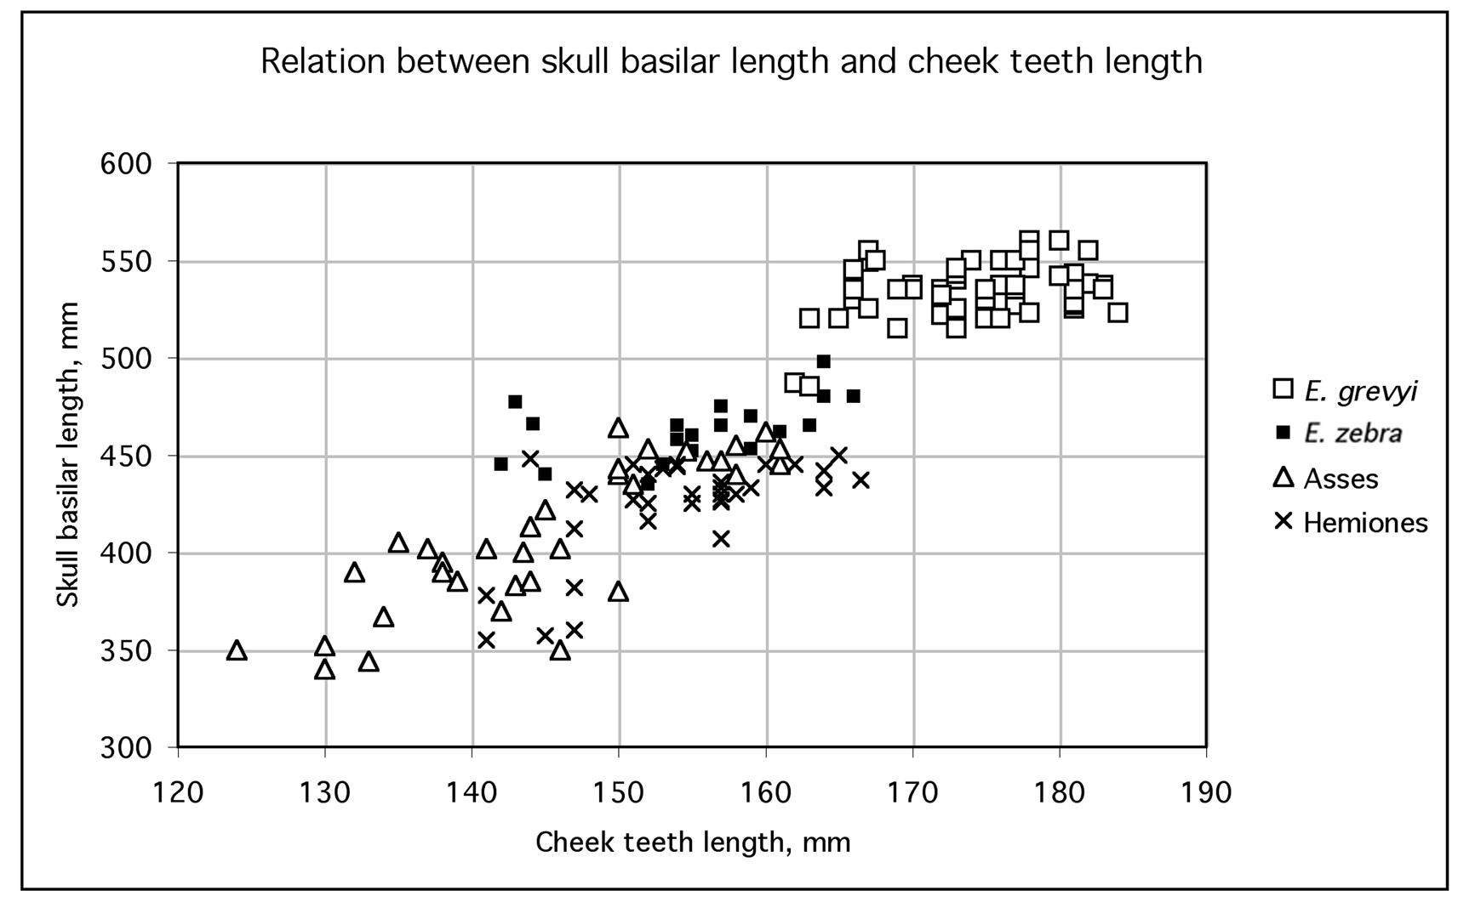

Appendix Fig. 3. Scatter diagram (in mm) of skull basilar length versus cheek teeth length based on 58 E. grevyi, 19 E. zebra, 34 Asses (14 E. asinus and 20 E. africanus), and 33 hemiones (E. hemionus and E. kiang).

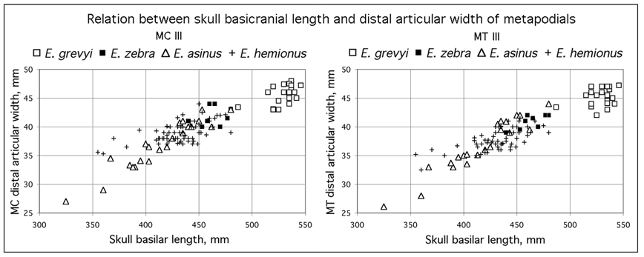

Appendix Fig. 4. Scatter diagram (in mm) of distal articular width of MC III versus skull basilar length (left) based on 24 E. grevyi, 8 E. zebra, 22 E. asinus, and 65 E. hemionus. Scatter diagram (in mm) of distal articular width of MT III (right) versus skull basilar length based 24 E. grevyi, 8 E. zebra, 21 E. asinus, and 63 E. hemionus.

ACKNOWLEDGEMENTS

A simple look at the 'abbreviations for collections' at the beginning of the paper will show to how many colleagues and/or curators we are indebted for in this work. Other studied collections are referred to in the text without appearing in the list. We wish in particular to thank Dr. Deng Tao of the Institute of

219

Vertebrate Palaeontology and Palaeoanthropolgy (Beijing) and Prof. Xue Xiang-Xu of of the Northwest University, (Xi'An, Shaanxi), China, as well as Dr Evangelia Tsoukala of the Thessaloniki University, Greece. If we have forgotten to mention or to thank some people, we beg them to forgive us.

Special thanks are due to Arthur H. Harris (El Paso, USA) and Gabriella Mangano (Palermo, Italy) for the communication of data and to Arthur H. Harris and Dr A. Athanassiou fot their careful reviews of our manuscript.

REFERENCES

ANTUNES, M. T., 2006.- The Zebro (Equidae) and its extinction in Portugal, with an Appendix on the noun zebro and the modern "zebra". 9th ICAZ Conference, Durham 2002. In: Equids in Time and Space, Oxbow Books, M. MASHKOUR ed., 17: 211-236.

AZZAROLI, A. & VOORHIES, M., 1993.- The Genus Equus in North America. The Blancan species. Palaeontographia Italica, 80: 175-198, 1 fig., 6 pl.

AZZAROLI, A. 1995.- A synopsis of the Quaternary species of Equus in North America. Bolletino della Societa Paleontologica Italiana, 34(2): 205-221.

AZZAROLI, A., 1998.- The Genus Equus in North America. The Pleistocene species. Palaeontographia Italica, 85: 1-60, 21 pl.

BONIFAY, M.-F., 1991.- Equus hydruntinus Regalia minor n.ssp. from the caves of Lunel-Viel (Hérault, France) In : Equids in the ancient world, vol. II, eds : R.H. MEADOW & H.-P. UERPMANN, Beihefte zum Tübinger Atlas des Vorderen Orients, Reihe A (Naturwissenschaften), Nr. 19/2, Dr Ludwig Reichert Verlag, Wiesbaden: 178-216, 16 fig., 1 pl.,14 tabl.

BOULE, M. & TEILHARD DE CHARDIN, P., 1928.- Paléontologie, Equus hemionus, in: Le paléolithique de la Chine, Archives de l'institut de Paléontologie Humaine, 4: 36-46, pl. XIII-X.

BURKE, A., EISENMANN, V., AMBLER, G., 2003.- The systematic position of Equus hydruntinus, an extinct species of Pleistocene equid. Quaternary Research, 59: 459-469.

COPE, E., 1893.- A preliminary report on the vertebrate paleontology of the Llano Estacado. 4th Annual report of the Geological Survey of Texas, Part II: 1-87.

DALQUEST, W.W., 1967.- Mammalls of the Pleistocene Slaton Local fauna of Texas. The Southwestern Naturalist, 12: 1-30.

DALQUEST, W.W., 1977.- Mammals of the Holloman local fauna, Pleistocene of Oklahoma. The Southwestern Naturalist, 22(2): 255-268.

DALQUEST, W.W. & HUGHES, J.T., 1965.- The Pleistocene Horse Equus conversidens. The American Naturalist. Notes and discussions: 241-244.

DENG, T. & XUE, XIANG-XU, 1999.- Chinese Fossil Horses of Equus and Their Environment. China Ocean Press, in Chinese, 158pp, 20 pl., 15 fig., 37 tabl. English abstract : 129-153.

DENZAU, G. & H., 1999.- Wildesel. Jan Thorbecke Verlag, Species 3, Stuttgart, 221 pages.

DOWNS, Th. et MILLER, G.J., 1994.- Late Cenozoic Equids from Anza-Borrego Desert of California. Contributions in Science of the Natural History Museum of Los Angeles County, 440: 90pp., 31 fig., 9 tabl.

EISENMANN, V., 1979.- Etude des cornets des dents incisives inférieures des Equus actuels et fossiles. Palaeontographia italica, 71 (n.s. 41): 55-75, 3 fig., 2 pl., 3 tabl.

220

EISENMANN, V., 1998.- Folivores et tondeurs d'herbe : forme de la symphyse mandibulaire des Equidés et des Tapiridés (Perissodactyla, Mammalia). Géobios, 31(1): 113-123, 5 fig., 1 tabl.

EISENMANN, V., 2003.- Gigantic Horses. Advances in Paleontology ‘Hen to Panta’, papers in honour of C. Radulescu and P.M. Samson. Bucharest: 31-40, 5 figures, 2 tables.

EISENMANN, V. & MASHKOUR, M., 1999.- The small equids of Binagady (Azerbaidjan) and Qazvin (Iran) : E. hemionus binagadensis nov. subsp., and E. hydruntinus. Géobios, 32(1): 105-122, 18 fig., 10 tabl.

EISENMANN, V. & MASHKOUR, M., 2000.- Data base for Teeth and Limb Bones of Modern Hemiones. Fiches d’Ostéologie animale pour l’Archéologie, Série B : Mammifères, 9, 46pp, 3 fig., 4 pl., 28 tabl. Centre de Recherches Archéologiques du CNRS, APDCA, Juan-les-Pins.

EISENMANN, V., & KUZNETSOVA, T., 2004.- Early Pleistocene equids (Mammalia, Perissodactyla) of Nalaikha (Mongolia) and the emergence of modern Equus. Geodiversitas 26(3): 535-561.

EISENMANN, V., 2006a.- Discriminating Equus skulls: The Franck's Index and the new Palatal Index. 9th ICAZ Conference, Durham 2002. In: Equids in Time and Space, Oxbow Books, M. MASHKOUR ed., 13: 172-182, 13 figs.

EISENMANN, V., 2006b.- Pliocene and Pleistocene Equids: Paleontology versus Molecular Biology. In: KAHLKE, R.-D., MAUL, L. C. & MAZZA, P. (Eds.): Late Neogene and Quaternary biodiversity and evolution: Regional developments and interregional correlations. Proceedings volume of the 18th International Senckenberg Conference (VI International Palaeontological Colloquium in Weimar), 25th-20th April 2004. Courier Forschungsinstitut Senckenberg (CFS), 256: 71-89, 21 figs, 2pls.

EISENMANN, V. & GERAADS, D., 2007.- Hipparion pomeli sp. nov from the late Pliocene of Ahl al Oughlam, Morocco, and a revision of the relationships of Pliocene and Pleistocene African hipparions. Paleontologia Africana 42: 51-98, 34 figs, 20 tab. + Appendix, 10 figs, 2 tab.

FORONOVA, I., 2006.- Late quaternary equids (genus Equus) of South-western and South-central Siberia. 9th ICAZ Conference, Durham 2002. In: Equids in Time and Space, Oxbow Books, M. MASHKOUR ed., 2: 20-30, 18 fig., 5 tabl.

GADJIEV, V.G., 1953.- Binagadinskij iskopaiemyj osel Equus cf. hydruntinus Reg. Binagadinskoie mestonakhojdenie chetvertichnoj fauny i flory, III. Trudy estestvenno-istoricheskogo museia im. G. Zardavi 6: 5-156, 29 fig., 39 tabl., Baku.

GIDLEY, J. W., 1900.- A new species of Pleistocene horse from the Staked Plains of Texas. Bulletin of the American Museum of Natural History 13: 111-116.

GROVES, C.P., 1966.- Taxonomy . In : GROVES, C.P., ZICCARDI, F., TOSCHI, A., Sull'asino selvatico africano. Supplemento alle Ricerche di Zoologia Applicata alla Caccia, 5(1): 2-11, 2 fig. Bologna.

HARINGTON, C.R. & CLULOW, F.V., 1973.- Pleistocene Mammals from Gold Run Creek, Yukon Territory. Canadian Journal of Earth Sciences, 10: 697-759.

HAY, O.P., 1915.- Contributions to the knowledge of the mammals of the Pleistocene of North America. Proccedings of the U. S. National Museum, 48: 515-575.

HIBBARD, C.W., 1953.- Equus (Asinus) calobatus Troxell and associated Vertebrates from the Pleistocene of Kansas. Transactions of the Kansas Academy of Science, 56(1):111-126.

HIBBARD, C.W., 1955.- Pleistocene vertebrates from the Upper Becerra (Becerra Superior) Formation, Valley of Tequixquiac, Mexco, with notes on other Pleistocene forms. Contributions of the Museum of Paleontology of the University of Michigan, 12: 47-96.

HIBBARD, C.W. & TAYLOR, D.W., 1960.- Two Late Pleistocene Faunas from Southwestern Kansas. Contributions from the Museum of Paleontology, The University of Michigan, 16(1):1-223, 18 fig., 16 pl.
221

HIBBARD, C.W & DALQUEST, W.W., 1966.- Fossils from the Seymour Formation of Knox and Baylor Counties, Texas, and their bearing on the Late kansan climate of that region. Contributions from the Museum of Paleontology of the University of Michigan, Ann Arbor, 21: 1-66.

HOWE, J.A., 1979.- Pleistocene Equidae from Sheridan County, Nebraska. Journal of Paleontology, 53(5): 1128-1236.

HULBERT, R.C. Jr., 1995.- Equus from Leisey Shell Pit 1A and other Irvingtonian localities from Florida. Bull. Florida Mus. Nat. Hist. 37(II): 553-602.

KURTEN, B. & ANDERSON, E., 1980.- Pleistocene Mammals of North America. Columbia Univ. Press, New York : 442p., fig., tabl.

LAZAREV, P.A., 1980.- Antropogenovye loshadi Iakutii. Moskva, Nauka, 190 pp., 21 pl., 47 fig., 18 tabl.

LUNDELIUS, E.L. & STEVENS, M.S., 1970.- Equus francisci Hay, a small stilt-legged horse, Middle Pleistocene of Texas. Journal of Paleontology, 44(1):148-153, 3 fig.

MOOSER, O., 1958.- La fauna "Cedazo" del Pleistoceno en Aguascalientes. An. Del Inst. de Biologia Mexico, 29: 409-452.

MOOSER, O. & DALQUEST, W.W., 1975.- Pleistocene mammals from Aguascalientes, Central Mexico. J. of Mammalogy, 56: 781-820.

OAKENFULL, E.A., LIM, H.N., RYDER, O.A., 2000.– A survey of equid mitochondrial DNA : Implications for the evolution, genetic diversity and conservation of Equus. Conservation Genetics 1: 341-355.

ORLANDO, L., EISENMANN, V., REYNIER, F., SONDAAR, P., HANNI, C., 2003.- Morphological convergence in Hippidion and Equus (Amerhippus), Southern-American Equids elucidated by ancient DNA analysis. J. of Molecular Evolution vol 57; supp/1; S29-S40.

ORLANDO, L., MASHKOUR, M., BURKE, A., DOUADY, C. J., EISENMANN, V., HANNI, C., 2006.- Geographic distribution of an extinct equid (Equus hydruntinus: Mammalia, Equidae) revealed by morphological and genetical analyses of fossils. Molecular Ecology 15: 2083-2093. Blackwell.

OSBORN, H. F., 1929. - The Titanotheres of ancient Wyoming, Dakota and Nebraska. Monogr. US. geol. Surv., 55(1), 701pp, 639 fig., 42 pl.; vol. 2 : 703-894, fig. 640-760, pl. 42-236. Washington.

QUINN, J. H., 1957.- Pleistocene Equidae of Texas. Bureau of Economic Geology, University of Texas, Report of Investigations 33: 51pp.

SCHREIBER, A., EISENMANN, V., ZIMMERMANN, W., 2000.- 2. Hemiones: Pluridisciplinary quest of their identities and relationships. In: EEP, Asiatic Equids, Husbandry Guidelines, 1-34. Zoologischer Garten Köln, Edited by W. ZIMMERMANN.

SKINNER, M.F., 1942.- The fauna of Papago Springs Cave, Arizona, and a study of Stockoceros; with three new antilocaprines from Nebraska and Arizona. Bulletin of the American Museum of Natural History, 80(6): 143-22O, 19 fig., New York.

SKINNER, M.F., HIBBARD, C.W., 1972. - Early Pleistocene preglacial and glacial rocks and faunas of North-Central Nebraska. Bulletin of the American Museum of Natural History, 148(1), 148p., 60 fig., 21 tabl., New York.

SLAUGHTER, B., CROOK, W., HARRIS, R., ALLEN, D., SEIFERT, M., 1962.- The Hill-Schuler local faunas of the Upper Trinity River, Dallas and Denton Counties, Texas. University of Texas Bureau Econ. Geol. report Investigations, 48, 1-75.

STEHLIN, H.G. & GRAZIOSI, P., 1935.- Ricerche sugli Asinidi fossili d'Europa. Mémoires de la Société Paléontologique Suisse, 56 (3): 1-73.

TROXELL, E. L., 1915.- The Vertebrate Fossils of Rock Creek, Texas. American Journal of Science,
222

39 (234): 613-638, 1 pl., 24 fig.

TSOUKALA, E., 1991. - Contribution to the study of the Pleistocene fauna of large mammals (Carnivora, Perissodactyla, Artiodactyla) from Petralona Cave (Chalkidiki, N. Greece. Preliminary report. C.R.Ac.Sc., 312(II): 331-336, 2 tabl., Paris.

VOGT, T., ERBAEVA, M., VOGT, H., 1995.– Premières preuves de conditions périglaciaires au Pléistocène inférieur en Transbaïkalie (Sibérie, Russie). C.R. Acad. Sci. Paris, 320(II a): 861-866.

WEINSTOCK, J., WILLERSLEV, E., SHER, A., TONG, W., HO, S.Y.O., RUBENSTEIN, D., STORER, J., BURNS, J., MARTIN, L., BRAVI, C., PRIETO, A., FROESE, D., SCOTT, E., XULONG, L., COOPER, A., 2005.- Evolution, Systematics, and Phylogeography of Pleistocene Horses in the New World: A Molecular Perspective.– PLoS Biology, (3)8: e241.

WINANS, M.C., 1985.- Revision of North American fossil species of the genus Equus (Mammalia : Perissodactyla : Equidae). Dissertation, Univ. of Texas : 264pp., 26 fig., tables, Austin.

ZHOU, Xinxue, SUN, Yufeng, WANG, Zhiyan, WANG, Hui, 1990.- Dalian Gulongshan yizhi yanjiu (Gulongshan cave site, (A Upper Paleolithic site at Dalian city). Beijing kexue jishu chubanshe (Beijing Scientific and Technical Publishing House): 94 pp., 4 pl., 20 fig, 26 tabl., Abstract: 81-86.

223

ANNEXE
(Tables)

