180

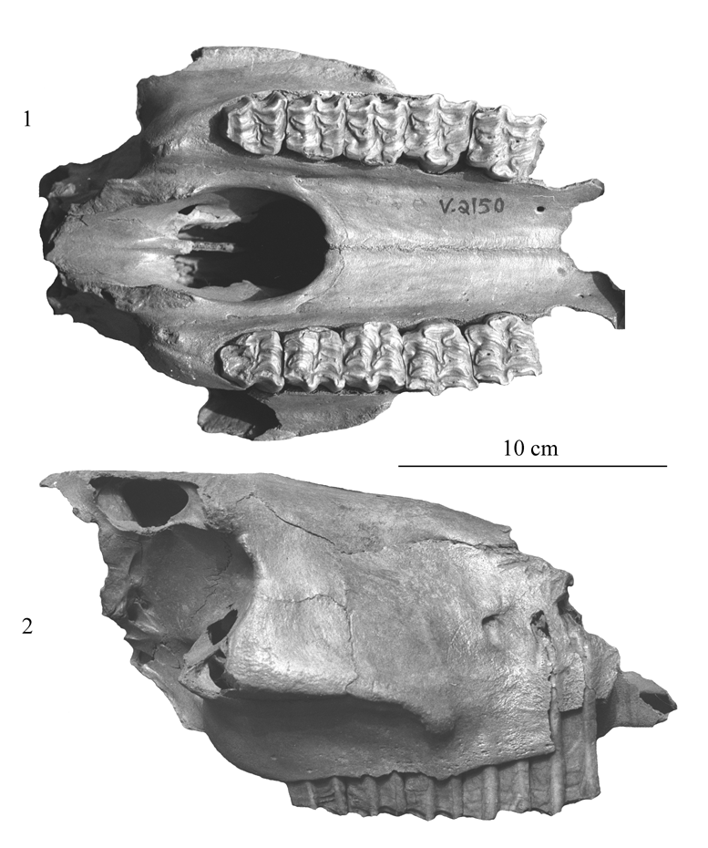

Figure 25. Skull fragment V 2150 from Jiling. Occlusal (1) and profile (2) views. Data in Table 1.

181

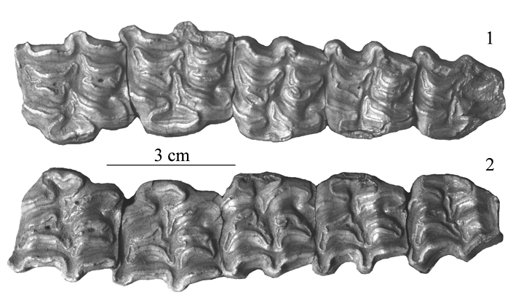

Figure 26. Upper cheek teeth of V 2150, Jiling. 1: left. 2: right.

7. Gulongshan Cave, Dalian, China

From the Late Pleistocene of this cave, Zhou et al. (1990) published a discriminant analysis of the numerous metacarpals belonging to caballines and hemiones. Unfortunately they provided no data on the MT III.

The metacarpals are smaller than at Tologoj. They are rather smilar to E. hydruntinus but larger (Fig.27).

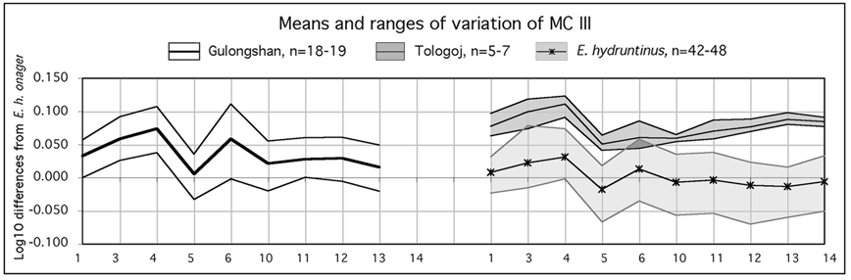

Figure 27. Ratio diagrams of third metacarpals (MC III) of Gulongshan, Tologoj, and E. hydruntinus. Data Xuexin et al., and Tables 3-4.

8. Conclusion

Thus, to our present state of knowledge, the Old World group of hemiones comprises the extant species E. hemionus with various subspecies, the recently extinct E. hydruntinus, and the pre-Würmian E. binagadensis. E. hydruntinus differs from other hemiones by its microdonty and its small protocones. The skull of E. hydruntinus (Fig.28) is characterized by its very short naso-incisival notch (31), and possibly by its
182

rather caballine Basion-vomer-palate proportions (3,4). E. binagadensis sems also to have the same kind of proportions and a specially short and wide muzzle (5,17,17bis). The Sjara-osso-gol Equus belongs to E. hemionus. The status of Jiling'skull is unclear, probably a local extinct small subspecies of E. hemionus.

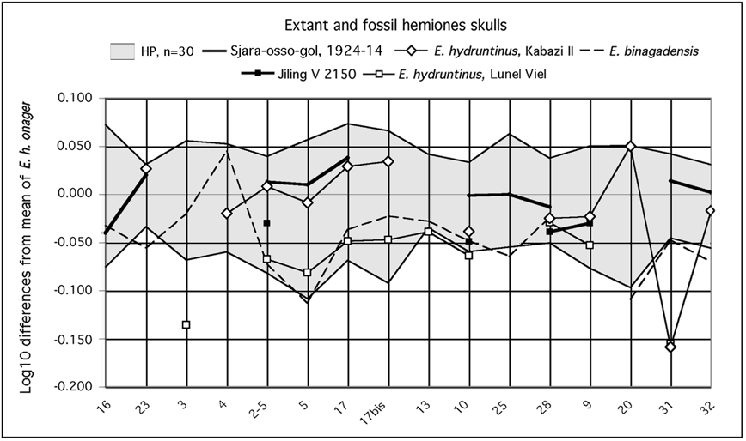

Figure 28. Ratio diagrams of extant and fossil hemiones skulls. Data in Table 1.

Almost all studied metapodials enter within the range of variation of extant E. hemionus (Fig.29). The most atypic are found in China (Jiling) and South Central Siberia (Kurtak).

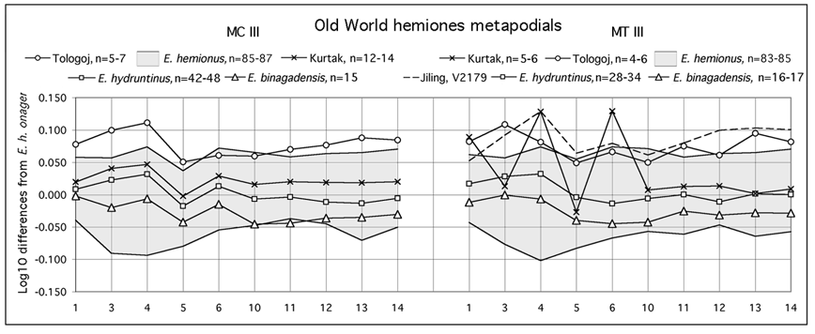

Figure 29. Ratio diagrams of Old World hemiones third metacarpals (MC III) and metatarsals (MT III). Measurements in Tables 3-4. n=number of specimens.

183

Altogether, the variability of Old World extant and fossil hemiones is not very large except in the cheek teeth patterns.

SUSSEMIONES

From around 1.5 to 0.5 Myr ago, a group of Equus informally named 'Sussemiones' (Eisenmann 2006b) is quite well represented in the Old World. It comprises robust as well as slender species. The slenderest (E. granatensis of Venta Micena, E. hipparionoides of Akhalkalaki) have small protocones like E. hydruntinus, but as with the hemione of Tologoj they are not very microdont. Anyway, Sussemiones differ from other Equus, in particular hemiones and E. hydruntinus, by quite unique cheek teeth enamel patterns.

On the lower cheek teeth the frequence of stylids, sometimes isolated, is remarkable. Plis protostylids occur on P/2 (Fig.30-1) and may be very developed on P/3-M/2 (Fig.30-2). True ectostylids may be present (Figure 30-3) as well as very developed or even isolated hypostylids (Fig.30-5). The shape of the double knot of many lower premolars resembles some extant hemiones, but in an extreme way (Figure 30-4): the metaconid is elongated, sometimes bilobated, the lingual valley is at times nearly absent. Unlike extant hemiones, another particularity is the frequency of very deep vestibular valleys, on molars (Fig.30-4) and even on some premolars.

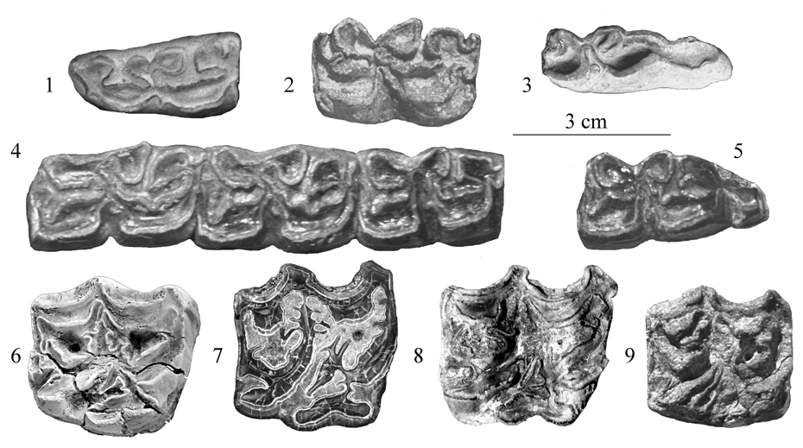

Fig.30. Sussemiones cheek teeth. 1: E. granatensis, Venta Micena, lower P2, VM 3572. 2: E. cf. suessenbornensis, Akhalkalaki, lower P4, TB 99. 3: E. granatensis, Venta Micena, lower M3, VM 84-C3-J9-16. 4: Equus sp., Krestovka, lower P3-M1, SI 851-74/8. 5: E. verae, Chukochya Loc 21, lower M3, SI 835-123. 6: Equus sp., Melka Kunture, Garba IV, upper P3 or P4, MK 74-7150. 7: E. cf. verae, Loc 26, upper P3 or P4, SI 2998-243. 8: E. suessenbornensis, upper P3 or P4, S 17-5226. 9: E. hipparionoides, Akhalkalaki, upper P4, TB 100.

184

But the depth of the vestibular valley is very variable: associated teeth may have very deep and very shallow valleys. Both features are uncommon in extant species.

On the upper cheek teeth, the most strange are the plis caballin. They often have a very large base (Fig.30-6,7), may be multiple (Fig.30-8), club-shaped (Fig.30-9). Such morphologies are unknown in extant species. They are frequent in Alaska, Chukochya, and at Süssenborn, but they occur even in Ethiopia, at Melka Kunturé (Figure 30-6). The enamel is often very plicated and the postprotoconal valley may be very deep (Fig.30-7).

The skull of E. coliemensis IA 1741 (Early Middle Pleistocene of North-Eastern Siberia, Lazarev 1980) belongs to this group (Eisenmann and Kuznetsova 2004, Eisenmann 2006b). It resembles extant hemiones (Fig.31).

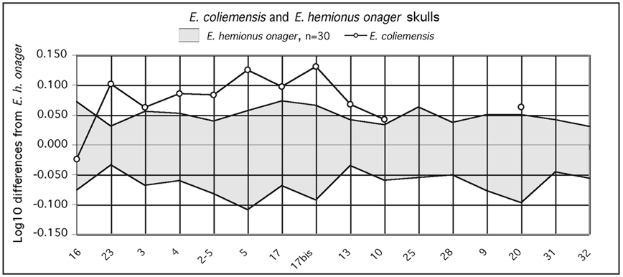

Figure 31. Ratio diagram of E. coliemensis skull compared to extant E. hemionus onager. Data in Table 1.

The occurrence in Sussemiones of Old World hemione characters, such as slenderness, elongated metaconids, relative microdonty and small protocones, in association with clearly apomorphic enamel patterns (shared by robust species of Sussemiones) seems to indicate that the 'slender, hemione-hydruntinus model' was quite widespread in time and geography.

STILT-LEGGED AND HEMIONE-LIKE EQUUS OF NORTH AMERICA

Since hemiones are characterized by slender limb bones that separate them easily from other extant Old World Equus, they should be easily identifiable in North America. It is however very difficult, because in North America, contrary to the Old World, posssible hemiones were not the only slender species to be found during the Quaternary. Since Troxell (1915) described E. calobatus as 'he who walks on stilts', the locution, 'stilt- legged' is applied to them. Regardless of their relationships, to true

185

hemiones or to stilt-legged equids, slender boned species ranged at least from the Late Blancan to the Rancholabrean, from Mexico to Alaska, and varied in size from gigantic to very small.

The recognition of the hypothetical first hemione in North America is therefore linked to a better description and understanding of the 'stilt-legged' group.

Unfortunately, most of these fossils are not directly associated and many are fragmentary. As often in paleontology, some informative specimens, were 'referred' to species the types of which are less diagnostic. After giving a definition of the 'stilt-legged' group, we will consider the types, the really associated, and the obviously referrable fossils before discussing the rest of the material.

I. FIRST STILT-LEGGED EQUUS

Stilt-legged equids should be defined by the characteristic proportions of their limb bone segments rather by the slenderness of each individual bone or by teeth characters that may be found in other groups, in particular true hemiones. In stilt-legged equids, the length of the distal bones (metapodials and first phalanges, and to a lesser extent - radius) relative to the proximal ones (humerus, femur, and tibia), is exceptional. The nearest proportions we have been able to find are those of the camel (data from Osborn 1929), but the camel humerus is quite longer and its metatarsal quite shorter. Typical stilt proportions are only found found at Santo Domingo, in E. calobatus, and E. semiplicatus (Fig.32).

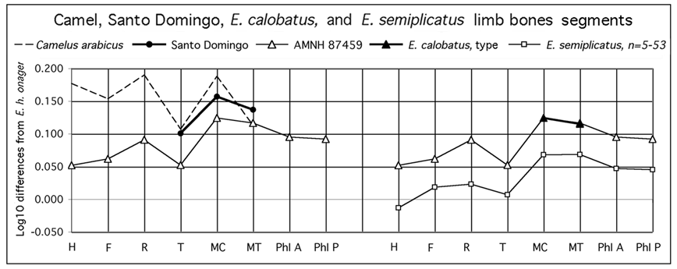

Figure 32. Ratio diagrams of limb bones segments in stilt-legged equids. Data in Table 2.

The first Equus appears to be Late Blancan (around 2 My ?). Actually there is no proof that it is not a Plesippus, since we do not know its skull. But we know that it was as large or larger than E. calobatus, and probably slightly smaller than the first Equus from Anza Borrego (Eisenmann 2006b). The associated bones (AMNH 11654) were found in New Mexico, in the Santo Domingo Basin (Azzaroli & Voorhies 1993).

186

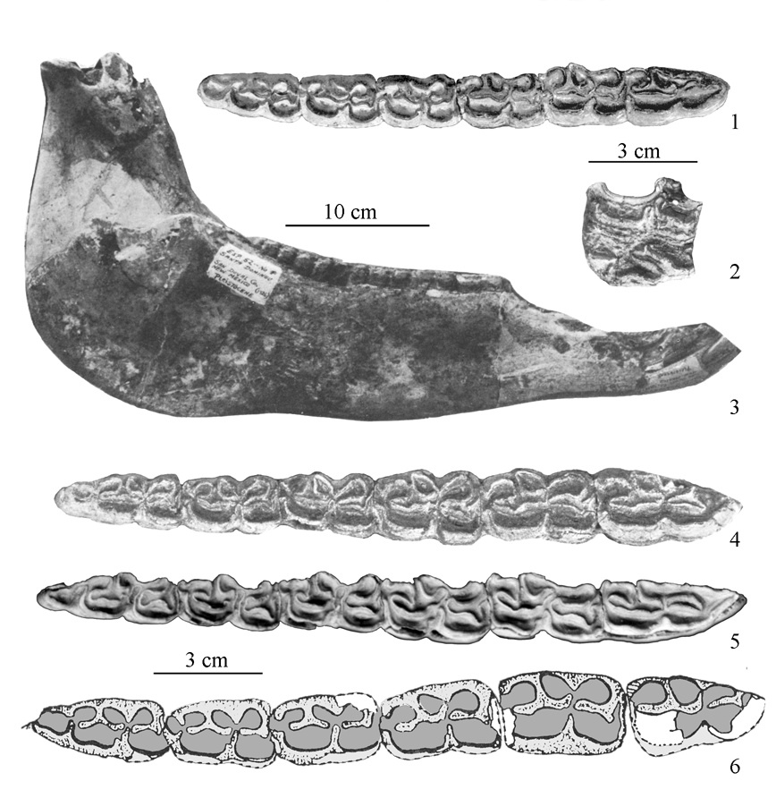

Figure 33. 1: Dry Mountains, AMNH 116502, lower P2-M3. 2: Santo Domingo, AMNH 116153, upper P3 or P4. 3: Santo Domingo, AMNH 116153, mandible. 4: Santo Domingo, AMNH 116153, lower P2-M3. 1-4 adapted from Azzaroli & Voorhies (1993). 5: Lost Chicken, lower P2-M3, courtesy A. Sher. 6: Anza Borrego, lower P2-M3, LACM-IVCM 2673, adapted from Downs & Miller (1994).

Beside a tibia and two metapodials, there are one mandible, with a long symphysis (Fig. 33-3), and an upper premolar. According to the size of the mandible (Appendix I, 3), the basilar lenghth of the skull was about 600mm long. The enamel pattern (Fig.33-2) of the upper premolar AMNH 116153 (Azzaroli & Voorhies 1993, Plate 4-4) is rather caballoid: long assymetrical protocone, pli caballin. The lower cheek teeth AMNH 116153 figured by Azzaroli & Voorhies (1993 Plate 4-3a) are more hemione-like (Fig.33-4) than those of Anza Borrego (Fig.33-6), but much less so than those of Dry Mountains, Arizona, AMNH 116502 (Fig.33-1) or the 'hyper-hemione' cheek teeth of Lost Chicken (Fig.33-5) both believed to be about the same age. The pattern is

187

similar to E. calobatus from Arkalon (Fig.37-1) and Seymour Formation (Fig.37-2).

There is no information on the limb bones of the Blancan Lost Chicken. The MT III found at Dry Mountains (Azzaroli and Voorhies 1993, Plate 6-3, AMNH 116501, is not slender indicating that an hemione-like pattern on lower cheek teeth is not necessarily linked with a stilt legged body. We have already noted the same for the Sussemiones of the Old World.

The metacarpal of Santo Domingo is similar to E. calobatus (Fig.34). The metatarsal is deeper in the diaphysis and has a more developed distal end.

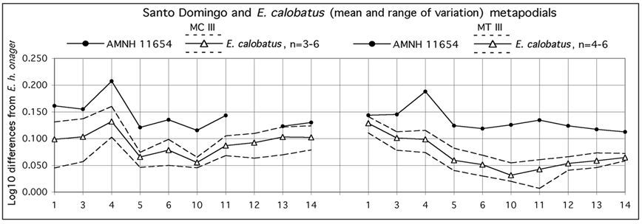

Figure 34. Ratio diagrams of third metacarpals (MC III) and metatarsals (MT III) of Santo Domingo and E. calobatus. n=number of specimens. Data in Tables 3-4.

II. LARGE AND MIDDLE SIZED STILT-LEGGED EQUUS

1. Localities and Chronology

The ages of E. calobatus and E. semiplicatus are not precise. It seems that the oldest finds are those of E. calobatus, inside the upper levels of Arkalon Gravel Pit, Meade Fm., Seward Co., Kansas, which could be early Pleistocene (Fig.35). E. semiplicatus appears later, at Channing, Dalhart, probably at the beginning of the middle Pleistocene. Both species seem to coexist at Rock Creek. E. cf. calobatus is present at Arkalon Terrace (possibly contemporary with Rock Creek) and at Hay Springs in the upper middle Pleistocene.

Rock Creek, Briscoe Co., Texas
Rock Creek is a name used to refer to several localities, more or less close to each other. The exact provenance and ages are not quite clear, probably early middle Pleistocene. Three equid species were described: E. scotti (several complete skeletons), E. calobatus (possibly associated metatarsal (MT) and metacarpal (MC)), and E. semiplicatus (one tooth). In his description of E. scotti, Gidley (1900) says that

188

the skeletons were found 'in a bed of compact sand at the head of Rock Creek, about the middle of the Equus, or Sheridan, beds, which are about 100 feet in thickness at this place'. Kurten and Anderson (1980) note that the main fauna comes from another quarry. Troxell (1915) states that the bones of E. calobatus were found at the Mylodon Camel Quarry. The type upper molar of E. semiplicatus comes from Tule Canyon (Rock Creek) and the referred upper series from Rock Creek beds (Quinn 1957). But the paratype of E. semiplicatus, a damaged upper molar, is from San Diego, Texas, far south of Rock Creek, as are the skull and metatarsal mentioned by Azzaroli (1998). While assignment of limb bones to E. scotti and E. calobatus is easy, the sorting out of the rest of the material is not, and the tentatives are subject to discussion.



Figure 35. Schematic chronology of Old and New World hemione-like equids.

2. E. calobatus

Mylodon Camel Quarry. Given the lack of certainty about the association of the MC (Table 3) and MT (Table 4), Hibbard (1953) proposed for type the MT III, PMYU

189

13470. It is very long and the diaphysis is very narrow resulting in a slenderness similar to extant hemiones. But the most striking character is the relative narrowness of the proximal and distal ends, reminiscent not of hemiones but of the smaller and extinct Old World E. hydruntinus. Azzaroli 1998 gave some dimensions of two other MT from Rock Creek (AMNH 116510 and TMM 41286-1).

The cotype third metacarpal (MC) of E. calobatus is very long and slender, as is the MT (Fig.36).

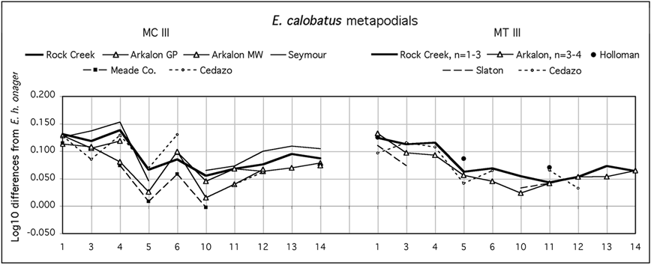

Fig. 36. Ratio diagrams of E. calobatus third metacarpals (MC III) and metatarsals (MT III). Data in Tables 3-4.

Obviously referable to E. calobatus because of size and slenderness are several first phalanges (Table 5), anterior and posterior, from Rock Creek, belonging also to Yale Peabody Museum collections. The anterior (PHI A) are numbered 19, 78, 142, and 3196-97. The posterior (PHI P) are numbered 3196-144 and -349.

Referred Material

Absolutely similar to the type and cotype are one MT (TMM 934-6) from Holloman, Gravel Pit, Frederick, Oklahoma, (Fig.36 right) described by Quinn (1957), and one MC (Fig. 36 left) from the Seymour Formation, Texas (UMMP 46555). Hibbard & Dalquest (1966) figured a sectioned lower series, UMMP 39382, from the Seymour Formation, which may belong to this species (Fig.37-2). A first posterior phalanx (UMMP 46509) belongs to the same form.

From Arkalon 1 Gravel Pit, Meade Fm., Seward Co., Kansas, associated limb bones of a subadult (FAM 87459) provide an excellent information on the general body proportions of this stilt-legged Equus (Table 2). The relations between limb segments lengths are surprising (Azzaroli 1998, Eisenmann 2003) and unknown in extant Equus (Fig.32). This partial skeleton was found at the top of the section, in the clay, silty, ash layer. The associated lower cheek series (Fig.37-1) was sectioned and figured by Skinner in Skinner & Hibbard (1972). It is 180mm long and quite similar to UMMP 39382 of Seymour

190

Formation (Fig.37-2) figured by Hibbard & Dalquest (1966).

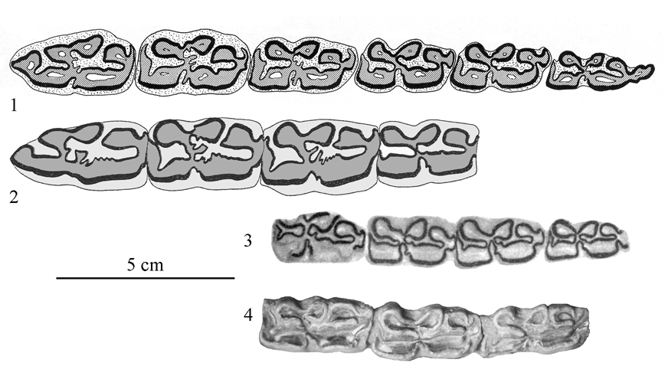

Fig.37.1: Arkalon Gravel Pit, FAM 87459, lower P2-M3, adapted from Skinner in Hibbard & Skinner (1972). 2: Seymour Formation, UMMP 39382, lower P2-M1, adapted from Hibbard & Dalquest (1966). 3: Cedazo, FC 58.16-18, lower P4-M3, adapted from Mooser (1958). 4: Hay Springs, UNSM 31.7.4.38, lower P4-M2.

An adult MC (Winans 1985) is slightly shorter than the juvenile FAM 87459. From a silty ash, near Arkalon, Hibbard (1953) mentioned a MT (UMMP 6842) 330mm long. Another MT (UMPP 29071) was also found in the upper levels of Arkalon.

From Meade County, Kansas, there is a juvenile MC preserved at Ann Arbor (UMMP 27023).

From Slaton, Texas. Slightly smaller but otherwise similar metatarsal and anterior first phalanx (TMM 882-337 and 285) were described by Dalquest (1967).

Some additional information comes from Mexico. From Cedazo, Mooser & Dalquest (1975) described a very long and slender MC (FC 705) and one MT (FC 703). The lower cheek teeth FC 56.16-18 from Cedazo (Fig.37-3) may also belong to E. calobatus.

So may the lower UNSM 31.7.4.38 from Hay Springs (Fig.37-4).

To summarize, we know that the USA E. calobatus was a tall horse, with very slender limb bones and strange limb proportions. There are no associated skull or
191

dentitions to the type. However on the basis of the cheek lengths and of the metapodial distal widths, the skull was about 500mm long (Apppendix 3, 4). The cheek teeth were about 180mm long. The double knot tended to be 'hemione-like' and the ectoflexid was shallow on the molars (Fig.37). The upper cheek teeth are unknown.

3. E. cf. calobatus

From Hay Springs, the little worn lower P4-M2 illustrated above show hemione-like features. The fragmentary MC (UNSM 6586) is less gracile but deeper in the diaphysis (Fig.38, Table 3), than in E. calobatus. Also from Hay Springs, a few MT or fragments of MT are more robust and with more developed distal ends than in E. calobatus (Fig.38, Table 4).

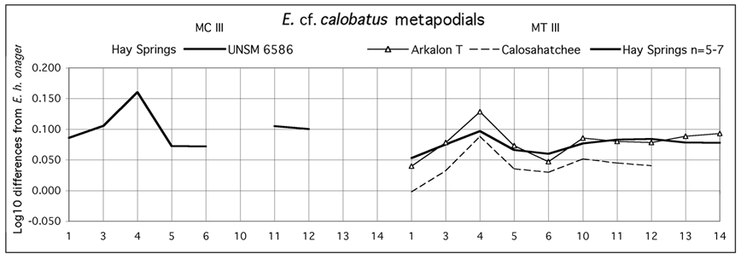

Figure 38. Ratio diagrams of E. cf. calobatus third metacarpals (MC III) and metatarsals (MT III). Data in Tables 3-4. Arkalon T=Arkalon Terrace.

At Arkalon 2 (Terrace 1-2) was found a MT III (UMMP 33358) shorter and not as narrow at the diaphysis and epiphyses as in E. calobatus (Fig.38, Table 2). A similar morphology is shown by a specimen from Calosahatchee, Florida (Field Museum of Chicago 14323).

Altogether, these bones are closer to hemiones than to stilt-legged forms because of their well developed distal epiphyses.

4. E. semiplicatus

a. Rock Creek and San Diego, Texas
The type (Tule Canyon, Rock Creek) is an upper molar with simple enamel and a tiny pli caballin. Judging from figure 2 in Plate XXIII of Cope (1893), it could be a right M2, about 26mm long and wide, with a protocone 15mm long (Fig.39-1).

Quinn (1957, Plate II-5) referred to E. semiplicatus an upper right series (TMM 276-2, Fig.39-3) from Rock Creek beds (166mm long) and Azzaroli (1998) a nearly complete skull (AMNH 8600) from San Diego. The cheek teeth series of the skull (Fig.

192

39-4) is 162mm long and the basilar length may be estimated at ca. 450mm (Appendix 3). The paratype fragmentary upper molar of E. semiplicatus (Cope 1893) comes also from San Diego Fig.39-2). It is slightly smaller (25mm) than the type.

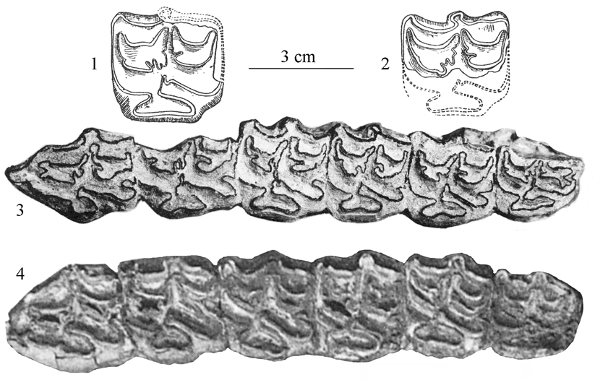

Figure 39. Upper cheek teeth of E. semiplicatus. 1: Tule Canyon, upper M1 or M2, adapted from Cope 1893. 2: San Diego, upper M1 or M2, adapted from Cope 1893. 3: Rock Creek, P2-M3, TMM 276-2, adapted from Quinn 1957. 4. San Diego, P2-M3, AMNH 8600, adapted from Azzaroli 1998.

Skull morphology will be discussed later, in comparison with specimens from Channing. Tooth morphology and size of TMM 276-2 and AMNH 8600 are compatible with the schematic illustration of the type upper molar of E. semiplicatus.

b. Hay Springs, Nebraska
One skull (UNSM 1349, Sheridan 2, U8) possibly belongs to E. semiplicatus (see below). The upper cheek teeth length is 163.3mm. Some specimens from Hay Springs are part of the collections of the Senckenberg Museum at Frankfurt. One is an upper cheek teeth series (M-1487). It is 161mm long; the enamel is not very plicated but the teeth are rather worn (Fig.40-1). This is the size of the teeth of the skull AMNH 8600 cited above. There are eight MC and five MT (Tables 1, 2) and seven anterior and five posterior first phalanges (Table 5) referrable to E. semiplicatus (Howe 1979). There are also at Hay Springs enigmatic hemione-like metapodials that we referred to E. cf. calobatus.

